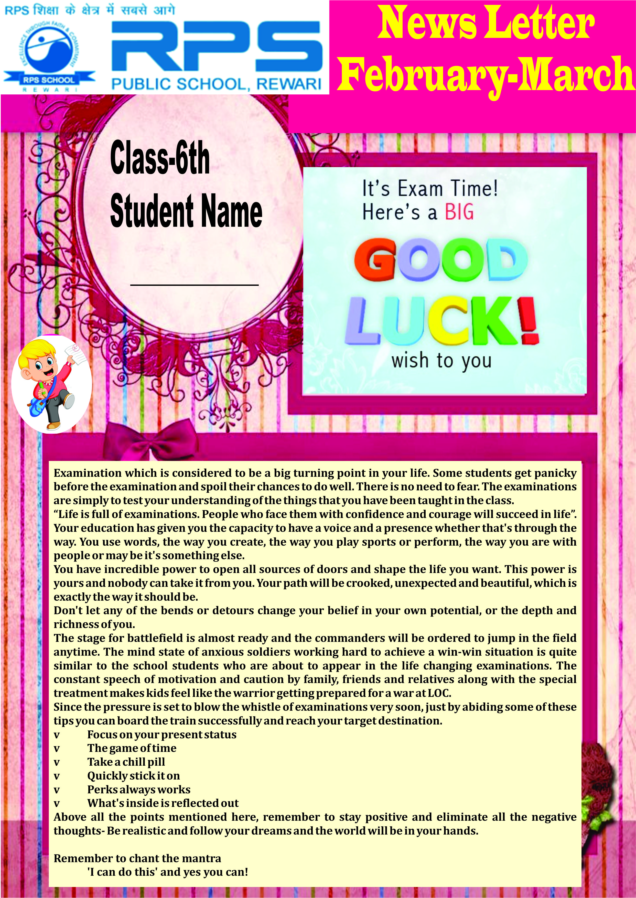
Class – 2nd
Student’s Name
S

Class 2nd–2nd Term Exams Date sheet
29-02-2020 | G.K.
02-03-2020 | Computer
04-03-2020 | Reasoning
05-03-2020 | Revision of Maths Subject in the school
06-03-2020 | Preparatory Leave
07-03-2020 | Maths
08-03-2020 | Sunday
11-03-2020 | EVS
12-03-2020 | Preparatory Leave
13-03-2020 | Hindi
14-03-2020 | Preparatory Leave
15-03-2020 | Sunday
16-03-2020 | English

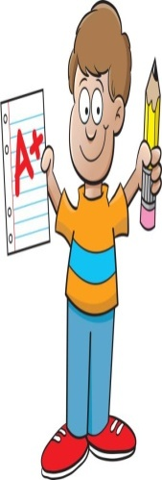

Note:-
- Result declaration will be 28th March,2020
- New session will be started on 30th March,2020. Kindly ensure the
presence of your ward on the first day of session 2020-2021
Syllabus and Blue Print Class- 2nd Term-2nd (2019-20)
Feb 2
No School
Computer M.M-40
Fill ups - 10 marks
True/False - 5 marks
Match ups - 5 marks
Identify the pic- 5 marks
MCQ’s - 10 marks
Q/Ans - 5 marks

Maths M.M-60
Multiplication - 5 marks
Division - 5 marks
Measurement - 5 marks
Geometry - 5 marks
Pattern - 5 marks
Addition - 5 marks
Subtraction - 5 marks
Even and Odd - 4 marks
MCQ’s - 8 marks
Mental Maths - 8 marks
Tables 2 to 15 - 5 marks

Reasoning M.M-50
Mental Ability - 20 marks
Rhyming Words - 5 marks
Jumbled word - 5 marks
Pattern - 5 marks
Classification - 5 marks
Mirror Half - 5 marks
Analogy - 5 marks

English M.M-60
Writing
Unseen Passage - 5 marks
Paragraph - 5 marks
Application - 5 marks
Literature
Fill ups - 5 marks
Puzzle - 4 marks
Tick the correct - 4 marks
True/False - 5 marks
Q/Ans - 10 marks
Dictation - 5 marks
Grammar
Synonyms - 2 marks
Antonym - 2 marks
Conjunction - 2 marks
Preposition - 2 marks
Six Question words - 2 marks
Articles - 2 marks

fgUnh
ys[ku M.M-60
vifBr xn~;ka’k & 5 Marks
vuqPNsn & 5 Marks
izkFkZuk &i= & 5 Marks
O;kdj.k
fdz;k & 2 Marks
loZuke & 2 Marks
fo’ks”k.k & 2 Marks
fnu vkSj eghus & 2 Marks
foykse ‘kCn & 2 Marks
fxurh & 3 Marks
iqLrd
iz’u@mRrj & 12 Marks
[kkyh LFkku & 5 Marks(5ques)
lgh@xyr fu’kku yxkvks & 5 Marks (5ques)
lgh feyku djks & 5 Marks(5ques)
Dictation - 5marks

EVS M.M-60
MCQ’s - 10 marks(1 marks each)
Fill ups - 7 marks(1 marks each)
True/False - 5 marks(1marks each)
Q/A Short - 5 marks(1 marks each)
Q/Ans - 10 marks(2 marks each)
Match ups - 8 marks ( 1 marks each)
Name these - 5 marks(1 marks each)
Identify the picture 5 marks (1 marks each)
Keywords - 5 marks

G.K. M.M-50
MCQ’s - 20 marks
Fill in the blanks- 5 marks
Picture based - 5 marks
Match ups - 5 marks
Puzzle solve - 5 marks
True/False - 5 marks
General Ques - 5 marks

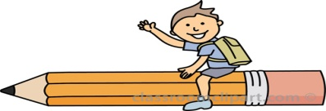

Date | Subject | Syllabus of Cyclic Test - I
11/2/2020 | G.K. | B.P.N. 51 to 64
11/2/2020 | Reasoning | Mental Maths , Pattern, Analogy, Classification
12/2/2020 | Hindi | Ch- 9, 10, 11, 13, 14, 15 GR.fnu vkSj eghus] fxurh] fdz;k] fo'ks"k.k] foykse 'kCn] esjk fiz; [ksy] esjk fiz; fe=] izkFkZuk&i=&vko';d dk;Z gsrq
13/02/2020 | English | Ch- 6,7,8,9 GR. - App. Urgent Piece of work and S.L.C., My Best  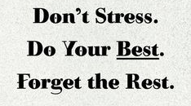  Friend, My Father, Six Question word, Word Contraction
14/02/2020 | Maths | Unit- 9, 10, 11, 13, 14, 15
15/02/2020 | E.V.S | Ch- 7, 8, 9, 11, 12, 13
Date | Subject | Syllabus of Cyclic Test - II
19/02/2020 | G.K. | Complete S.A- II Syllabus(B.P.N. 39 to 73)
19/02/2020 | Reasoning | Rhyming words, Jumbled Words, Mirror Half + Cyclic Test - I syllabus
20/02/2020 | Hindi | Ch-1, Ch- 12 , GR. - izkFkZuk&i= &chekjh dh NqV~Vh ds fy, ] lekukFkhZ 'kCn] Cyclic Test - I syllabus
21/02/2020 | English | Ch-4 Gr. Synonyms, Antonyms, Has/Have/Had, Articles,  Conjunction, Preposition, App. - Sick Leave + Cyclic Test-I syllabus
22/02/2020 | Maths | Unit - 12 + Cyclic Test - I syllabus, Addition & Subtraction
24/02/2020 | E.V.S. | Ch-4,5,10, My Self + Cyclic Test- I syllabus

fgUnh
ys[ku M.M-60
vifBr xn~;ka’k & 5 Marks
vuqPNsn & 5 Marks
izkFkZuk &i= & 5 Marks
O;kdj.k
fdz;k & 2 Marks
loZuke & 2 Marks
fo’ks”k.k & 2 Marks
fnu vkSj eghus & 2 Marks
foykse ‘kCn & 2 Marks
fxurh & 3 Marks
iqLrd
iz’u@mRrj & 12 Marks
[kkyh LFkku & 5 Marks(5ques)
lgh@xyr fu’kku yxkvks & 5 Marks (5ques)
lgh feyku djks & 5 Marks(5ques)
Dictation - 5marks

fgUnh
ys[ku M.M-60
vifBr xn~;ka’k & 5 Marks
vuqPNsn & 5 Marks
izkFkZuk &i= & 5 Marks
O;kdj.k
fdz;k & 2 Marks
loZuke & 2 Marks
fo’ks”k.k & 2 Marks
fnu vkSj eghus & 2 Marks
foykse ‘kCn & 2 Marks
fxurh & 3 Marks
iqLrd
iz’u@mRrj & 12 Marks
[kkyh LFkku & 5 Marks(5ques)
lgh@xyr fu’kku yxkvks & 5 Marks (5ques)
lgh feyku djks & 5 Marks(5ques)
Dictation - 5marks

fgUnh
ys[ku M.M-60
vifBr xn~;ka’k & 5 Marks
vuqPNsn & 5 Marks
izkFkZuk &i= & 5 Marks
O;kdj.k
fdz;k & 2 Marks
loZuke & 2 Marks
fo’ks”k.k & 2 Marks
fnu vkSj eghus & 2 Marks
foykse ‘kCn & 2 Marks
fxurh & 3 Marks
iqLrd
iz’u@mRrj & 12 Marks
[kkyh LFkku & 5 Marks(5ques)
lgh@xyr fu’kku yxkvks & 5 Marks (5ques)
lgh feyku djks & 5 Marks(5ques)
Dictation - 5marks

fgUnh
ys[ku M.M-60
vifBr xn~;ka’k & 5 Marks
vuqPNsn & 5 Marks
izkFkZuk &i= & 5 Marks
O;kdj.k
fdz;k & 2 Marks
loZuke & 2 Marks
fo’ks”k.k & 2 Marks
fnu vkSj eghus & 2 Marks
foykse ‘kCn & 2 Marks
fxurh & 3 Marks
iqLrd
iz’u@mRrj & 12 Marks
[kkyh LFkku & 5 Marks(5ques)
lgh@xyr fu’kku yxkvks & 5 Marks (5ques)
lgh feyku djks & 5 Marks(5ques)
Dictation - 5marks

