December and January
NEWSLETTER

Practice and Will Power………………….Way to Success
The two important ingredients of success are ‘practice’ and ‘will power’ provided that an individual just keeps sticking to them until the ultimate fruit is procured in the form of success.

The old saying ’practice makes a man perfect’ holds its all time relevance. Without it, no person can achieve his desired goal. The God of cricket i.e. Sachin Tendulkar once started during the course of an interview that, if he did not devote time to practice, the impact could be seen on his game in the fields. It’s by virtue of this aspect only that a large number of people could carve their niche in their respective fields which otherwise could not have been possible.

Likewise, the quality of will power paves the path of success in the life of a person by constantly pushing him towards his goal. It is by dint of having strong will power only that so many people accomplish the seemingly impossible missions and emerge as victorious. Strong will power enables one to face great challenges in life. The quality of will power forces an individual to do miracles in terms of doing something extraordinary and set an example for others.

Therefore, these two aspects are worth infusing in your life which, to a great extent, are complementary to each other. Just follow the ‘practice’ of doing continuous practice with a fervour of strong will power and then see the output. Believe it, you shall come up with flying colours in all walks of life which is the desire of everyone.

So children, with this you are being handed over the edition of your December-January Newsletter. Hope that you will be benefitted and imbibe these great aspects leading yourself to success …………
Hope all of you scored good grades in your
exams. Those who didn’t do fairly well need
not worry but to introspect and find out
reason of poor performance. Introspection is a
very useful tool for one’s betterment. Watch
your own strategies and time management so
that you can find out where you are lacking.
Dear students the awareness of approaching
exams is enough to make you realize that you
should not waste your time on internet, mobile
phones, tv or gossiping. During this period you
should not allow anything to distract you.
As all of you know that winters are knocking at
the door. Winter is exam season. It is
important to maintain healthy body and mind
so that you can achieve good results. Beat the
winter blues and make best out, winters could
be one of the most productive season
academically if you conquer laziness and study
consistently for your exam.
The mantra and bottom line is:
“Arise, Away and stop not till the goal is
reached”. Swami Vivekanand.
Good Luck for your Exam.

Dear Student

Class – 2nd
Student Name
_______________

Our Festivals

Christmas is an festival commemorating the birth of Jesus Christ, observed on Dec 25 as a religious and cultural celebration among billions of people around the world. We celebrate it by social gathering symbolic decoration, throwing feast and giving gifts to friends and families.

On the night of 31st December and the morning of 1st January, we celebrate New Year. There have been celebrations to mark the beginning of a new year for thousands of years. Sometimes these were simply an opportunity for people to eat, drink and have fun, but in some places the festivities were connected to the land or astronomical events. All of us celebrate new year with full fun and enthusiasm.

Republic Day –Each year, 26th January is a day on which the heart of every Indian fills ups with patriotic fervor and immense love for motherland. There are many significant memories as on this day the Indian Tricolour was first unfurled in January 1930 at Lahore, by Pt. Jawaharlal Nehru and the declaration of an independent Indian National Congress was made.
26th January, 1950 was the day when the Indian Republic and its constitution came into force. It was the day in history in 1965 when Hindi was declared as the official language of India

MakarSankranti is a harvest festival celebrated in India. It is celebrated with pomp and show in almost all the states of India in various forms. It signifies the northward journey of Sun which is called ‘Uttarayan’. People discard old things for new ones, forget old enmities, pray to God and offer food to their ancestors with the start of the harvesting season and end of the winter months. People attend holy fairs like the ‘KumbMela’ in Prayag and the ‘Ganasagar Mela’ at the junction of River Ganges and the Bay of Bengal and take a dip in the holy waters to wash off their sins.

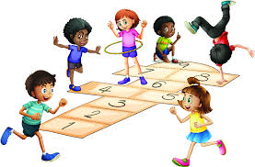
Syllabus of Dec.& Jan.

Subject | Month wise Plan  01/12/2019 AIDS Awareness Day  04/12/2019 Navy Day  10/12/2019 Human Rights Day  15/12/2019 to  22/12/2019 Maths Week  23/12/2019 KisanDiwas  25/12/2019 Christmas Day
English | Dec.  L-8 Pitpat’s Journey, L-9 Let’s Make Friends, Poem- The Song of Engine.  Gr. Application- Urgent Piece of Work, Picture Composition, Paragraph- My Best Friend, Story Telling- The Honest Woodcutter, Six Question words, Word Contractions.  Jan.  REVISION of UT-IV
Maths | Dec.  Unit-13 Patterns, Unit-14 Geometry, Unit-15 Measurement  01/01/2020 New Year.  13/01/2020 Lohri  14/01/2020 MakarSankranti  23/01/2020 NetajiSubhash  Chandra Bose B’day  26/01/2020 Republic Day  29/01/2020 Basant Panchmi  Jan.  REVISION of UT-IV
EVS | Dec.  Ch-11 Directions and Time, Ch-12 Our Country, Ch-13 Our Planet.  Jan.  REVISION of UT-IV + Activity
fgUnh | fnlacj  ikB &13 fpfM+;k dk xhr] ikB & 14 ‘ks:nk] ikB&15 ckjh ckjh vkrs ekSle  O;kdj.k & ys[ku] esjk fiz; [ksy] izkFkZuk&i= vko’;d dk;Z gsrq] fnu vkSj eghus] fp= & o.kZu ] fxurhA  tuojh  iqukjko`frA
G.K. | Dec.  B.P.N. 51 to 64, Differently able, Pattern fun, Capital cities to do, First-aid box, Famous people Story time, Let’s play it safe, Wonderful inventions, Water for life by rivers, Days to Celebrate  Jan.  REVISION of UT-IV
Computer | Dec.  Ch-7 Using Ms. Word 2010  Jan.  REVISION of UT-IV
Reasoning | Dec.  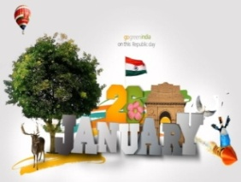  Mental Maths and Patterns  Jan.  REVISION of UT-IV

December
04/12/2019 Indian Navy Day(Special
Assembly)
10/12/2019 Human Rights Day(Special
Assembly)
12/12/2019 Story Telling
Competition (Class 1st & 2nd)
21/12/2019 Maths Quiz (Class 1st & 2nd)
23/12/2019 Farmer’s Day (Special
Assembly)
25/12/2019 Christmas Day & Tulsi Pujan
January
01/01/2020 New Year Celebration
10/01/2020 World Hindi Day(Skit of
Class 1st )
13/01/2020 Lohri Celebration
23/01/2020 Subhash Chandra Bose
Jayanti(Special Assembly)
25/01/2020 Republic Day Celebration

Sports Meet Ceremony
Objective Test Syllabus (23-12-2019)
Date | Day | Subject | Syllabus
24.01.2020 | Friday | Computer | Ch-7 & 8
25.01.2020 | Saturday | G.K. | B.P.N. 51 to 64, Differently able, Pattern fun, Capital cities to do, First-aid box, Famous people story time, Let’s play it safe, Wonderful Inventions, Water for life by rivers, Days to Celebrate
27.01.2020 | Monday | Reasoning | Menta; Maths and Patterns
28.01.2020 | Tuesday | Maths | Unit- 13 Patterns, Unit-14 Geometry, Unit-15 Measurement
29.01.2020 | Wednesday | Hindi | ikB&13 fpfM+;k dj xhr] ikB&14 ‘ks:nk] ikB&15 ckjh & ckjh vkrs ekSle  O;kdj.k &fnu vkSj eghus] fxurh] esjk fiz; [ksy] izkFkZuk &i= & vko’;d dk;Z gsrq] fp= &o.kZuA
30.01.2020 | Thursday | English | L-8 & 9 Gr. App. – Urgent Piece of work, Picture Composition, Paragraph- My Best Friend, Six question words, Word contractions
31.01.2020 | Friday | EVS | Ch-11 Directions and Time , Ch-12 Our Country, Ch-13 Our Planet

Hindi :- ikB&13 fpfM+;k dh xhr] ikB &14 ‘ks:nk O;kdj.k & fnu vkSj eghus ] fxurh

English :- L-8 Pitpat’s Journey, Poem- The Song of Engine, GR. & Six question words

Maths:- Ch-13 Pattern, Ch-14 Geometry

EVS :- Ch-11 Directions and time, Ch-12 Our Country
G.K. :- B.P.N. 51 to 55

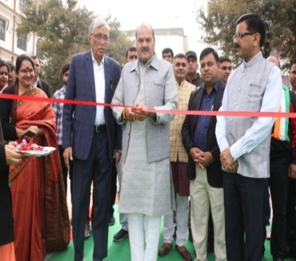
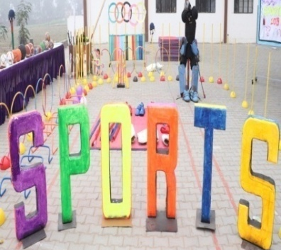

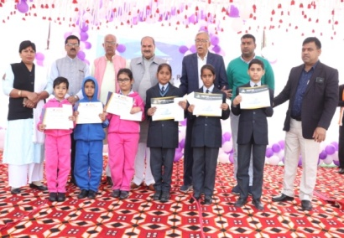
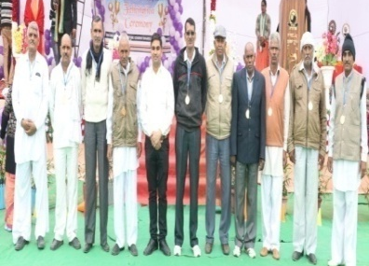

NOTE :-It is inform you that we are going to start giving off to classes L.K.G. to 5th on Second
Saturday of every month. It will start from the month of December.

Co-ordinator’s Sign Headmistress’s Sign Principal’s Sign

