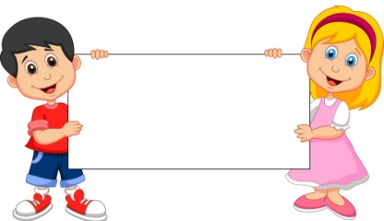
The Covenant
July& August

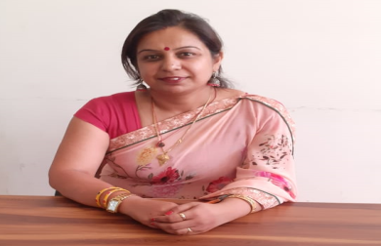
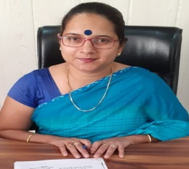
Dear Families,
When there is focus on etiquette there is real intelligence, this would be the best mind as I consider it. The word “Sanskar” means process of increasing potential in ourselves and which is
a process by which positive qualities in man are developed and enhanced is known as a Sanskar. It makes the mind set of an individual of a specific type. As per the science of psychology, there is a strong relationship between the mind set the goal to be achieved. What RPS Kosli is trying to give them ambience to live with hostility so that they learn to fight for their right and against nonsense of society, live with encouragement, to inculcate in them confidence, to live with praise, so that they can learn appreciation, live with acceptance so they can love humanity, to live with approval so that they start liking themselves instead of copying others and lose their own ethics, to live with sharing so that they can learn generosity live with honesty so that they can learn truthfulness, to live with fairness so that they can learn justice , to learn to live with friendliness, they learn the World is a nice place in which to live. This relevant learning and living becomes all the more significant in today’s World when both the young and the old are on mindless pursuit of intellectual gains.

With Regards
Ms. Pooja Trilok Sharma
Principal, RPS Kosli

Dear Families,
Welcome to RPS Public School,
Kosli. RPS prides itself on being a
caring community of learners that
fosters pride in each student’s
developing abilities while
promoting social development.
We build the essence of community each day in every classroom touching all of our students. We know that no meaningful learning can happen unless students feel safe. We use the responsive classroom approach to teach children to act responsibly, take responsibility and to treat each other with respect.
Our teachers use a variety of innovative instructional approaches to instill a love of learning and build confident, competent students. We focus on enhancing student’s ability to think critically and creatively. We are fortunate to have a strong, active, parents teachers interacting ways and we encourage all parents to fully cooperate. I also urge you to take an active part in what your child required to do at home and to support independent reading.
There is a lot of information contained in the school website and more will come each month from our school newsletter. In addition you should always know that all of us at RPS believe in communication. We are here for your students and for you.
With Regards
Ms. Pankaj Yadav
Headmistress, RPS Kosli

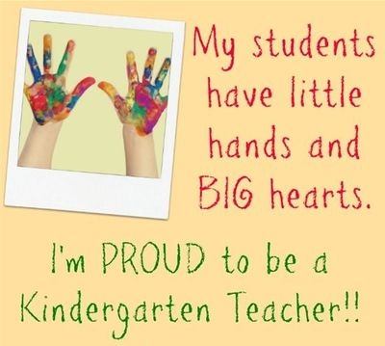
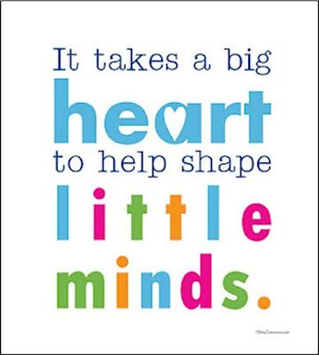

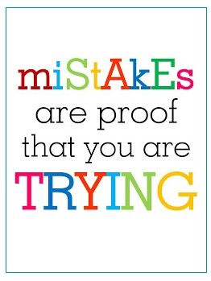
English In July – Book -2 Page No. 2 to 30
Work in Notebook – Consonants, The vowel ‘a’ two letter clusters – ab, ad, ag, am, an, ap, at words
In August – Book No. 3 Page no. 2 to 24
Work in Notebook – The vowel ‘e’ two letter cluster –ed, eg, en, et words. The vowel ‘I’ two letter clusters – ib, id, ig words

EVS In July – Book No. 2 Page no. 58 to 74
Work in Notebook – Colour’s Name, Rooms’ Name, Fruits’ Name, Safety Rules
In August - Book No. 3 Page No. 52 to 70
Work in Notebook – Classroom things, Community Helpers, Wild Animals, Domestic Animals

Unit Test-2 Date sheet & syllabus
fgUnh tqykbZ & ist+ ua0 & 12]13]14]15]16]17

jaxksa ds uke ] Qyksa ds uke] vk] b dh ek=k

vxLr & ist+ ua0 & 18]19]20]21]22]23
bZ ] m dh ek=k] fyax cnyks]
opu cnyks] tkuojksa ds uke

Date | Subject | Syllabus
29th July | Eng | Aa to Zz, What comes after, before, between, Two letter cluster words – ab, ad, am,at
30th July | Hindi | v ls K 1]2]3]4 v{kjksa dk tksM+] fp= ns[kdj igyk v{kj fy[kuk] vk dh ek=k
31st July | Maths | 1 to 100 numbers, what comes after, before, between, shapes- pentagon
01st Aug. | EVS | Colours name, Fruits name, Rooms Name

Maths In July – Book No. 2 Page no. 32 to 56
Work in Notebook - Missing numbers, Smaller and bigger number, Shape – Pentagon, Table of 2

In August - Book No. 3 Page no. 26 to 50
Work in Notebook- Thick-Thin, Front – Back, Shape- Hexagon, Table of 3

Examination Policy
Dear Parent,
It is to inform you that there is a change in “Examination Policy” by RPS group of institution in which no re-examination will be conducted for U.Ts, Mid term and Finals for any case ABSENT will be marked in the report card. So you are requested not to make your ward absent on the day of exam.
- Medical case can be considered in case of emergency for that submission of medical certificate is required.

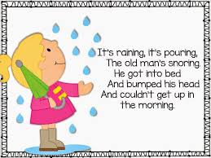
Rhymes & Stories
In July - Traffic Signal, Annie the ant, The honest wood cutter.
In August - Elly the elephant, The miller, his son and the donkey, Five friendly firefighters, People at work, Pat – a – cake

Date | Upcoming Events & Days for the Month of July
1st JULY | DOCTOR’S DAY
11th JULY | Pool Party
20th JULY | ENG POEM RECITATION COMPETITION
26TH JULY | KARGIL VIJAY DIWAS(SPECIAL ASSEMBLY)
30th JULY | Birthday & Green Day Celebration
Date | Upcoming Events & Days for the Month of AUG
3RD AUG | TEEJ CELEBRATION
7TH AUG | HINDI POEM RECITATION
8TH AUG | SENIOR CITIZEN DAY CELEBRATION
14TH AUG | RAKHI MAKING ACTIVITY
15TH AUG | INDEPENDENCE DAY CELEBRATION
23RD AUG | JANMASHTMI CELEBRATION
29TH AUG | INTER NATIONAL SPORTS DAY
31st AUG | Birthday and Pink Day Celebration
Communication Bites
2:00 | It’s two o’clock | 2:30 | It’s half past two.
2:05 | It’s five past two. | 2:35 | It’s twenty-five to three.
2:10 | It’s ten past two. | 2:40 | It’s twenty to three.
2:15 | It’s quarter past two. | 2:45 | It’s quarter to three.
2:20 | It’s twenty past two. | 2:50 | It’s ten to three.
2:25 | It’s twenty-five past two. | 2:55 | It’s five to three.
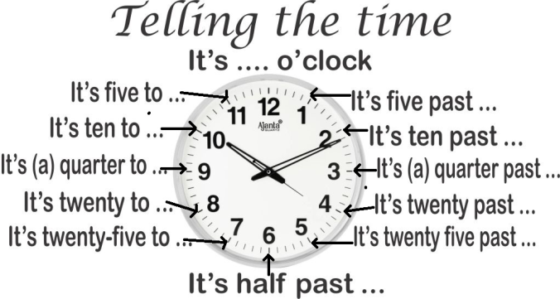

Birthday Celebration

WORLD HEALTH DAY
WE ARE GOING TO START WISHING TO OTHER WITH “PRANAM”
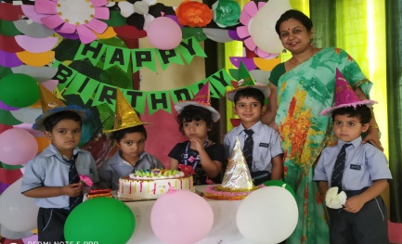
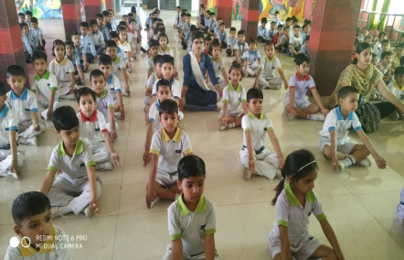

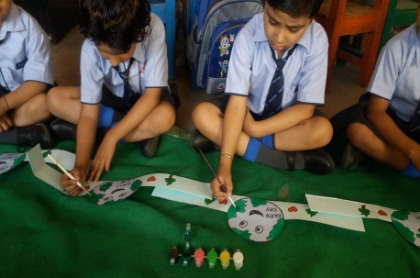

World Earth DAy

Mother’s Day

World Book Day
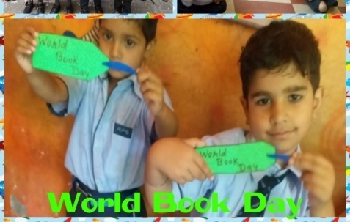
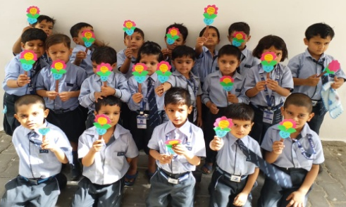

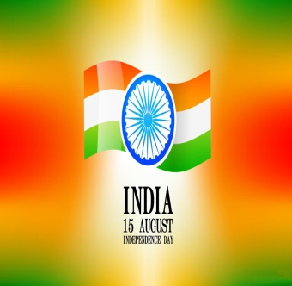
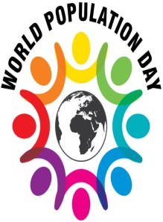
17thJuly :-World Day for International Justice
World day for International Justice, also referred as day of International Criminal Justice or International justice day, is an international day celebrated throughout the world on 17th July as part of an effort to recognize the emerging system of International criminal justice.

15th August:-Independence Day
Independence Day is annually celebrated on 15th August as red letter day in India on commemorating the nation struggle and immolation of our mighty freedom fighters. Every year on this day the Prime Minister addresses the nation from the ramparts of Red Fort.
11th July :-World Population Day
World Population Day is an annual event, observed on 11thJuly every year, which seeks to raise awareness of Global
population issues. The event was
established by the Governing Council of the United Nations Development
Programme in 1989.

25thJuly :-Women’s Equality Day
Women are treated as the Second Class Citizen in United State, nobody were allowed to vote Women, Women were not having full right in Govt. and Private jobs and institution. In the passage of 19th amendment of US constitution, Women got full rights everywhere.

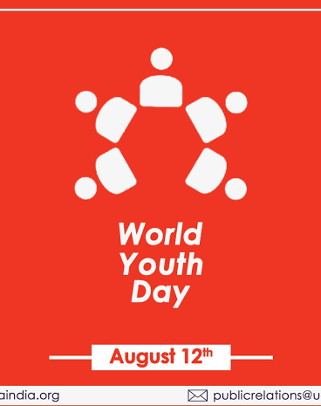
18th July :-Nelson Mandela Day
Nelson Mandela International Day is an annual international day in honour of Nelson Mandela, celebrated each year on 18th July as Mandela’s birthday. The day was officially declared by the United Nations in November 2009, with the UN Mandela Day held on 18th July, 2010

12th August:-International Youth Day
Youth is the Foundation of every Country. To Spread the awareness in Youth United Nation is celebrating International Youth Day on 12th August from 1999.
The Theme of IYD 2019 is Transforming Education.

29thJuly :-World Tiger Day
International Tiger Day is celebrated with the goal to promote a Global System for protecting the natural habitats of tigers in2010 at Sat Petersburg.

29thJuly :-World Tiger Day
International Tiger Day is
celebrated with the goal to promote
a Global System for protecting the
natural habitats of tigers in2010
at Sat Petersburg.

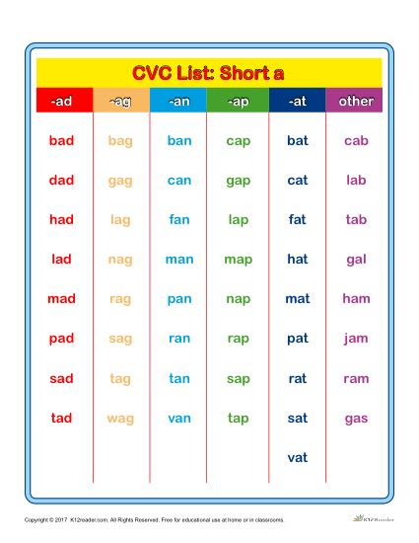
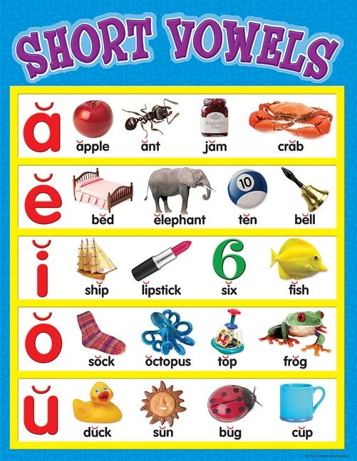

Coordinator’s Sign. Head Mistress’s Sign. Principal’s Sign.

