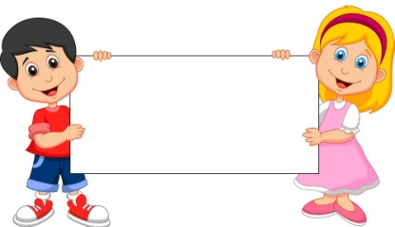
The Covenant
July& August

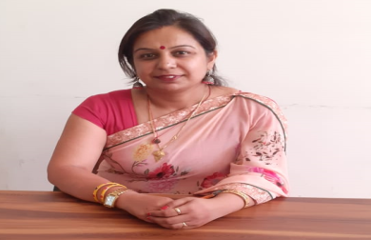
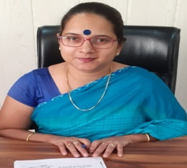

Dear Families,
When there is focus on etiquette there is real intelligence, this would be the best mind as I consider it. The word “Sanskar” means process of increasing potential in ourselves and which is
a process by which positive qualities in man are developed and enhanced is known as a Sanskar. It makes the mind set of an individual of a specific type. As per the science of psychology, there is a strong relationship between the mind set the goal to be achieved. What RPS Kosli is trying to give them ambience to live with hostility so that they learn to fight for their right and against nonsense of society, live with encouragement, to inculcate in them confidence, to live with praise, so that they can learn appreciation, live with acceptance so they can love humanity, to live with approval so that they start liking themselves instead of copying others and lose their own ethics, to live with sharing so that they can learn generosity live with honesty so that they can learn truthfulness, to live with fairness so that they can learn justice , to learn to live with friendliness, they learn the World is a nice place in which to live. This relevant learning and living becomes all the more significant in today’s World when both the young and the old are on mindless pursuit of intellectual gains.

With Regards
Ms. Pooja Trilok Sharma
Principal, RPS Kosli

Dear Families,
Welcome to RPS Public School, Kosli. RPS prides itself on being acaring community of learners that fosters pride in each student’s developing abilities while promoting social
development. We build the essence of community each day
in every classroom touching all of our students. We know that no meaningful learning can happen unless students feel safe. We use the responsive classroom approach to teach children to act responsibly, take responsibility and to treat each other with respect.
Our teachers use a variety of innovative instructional approaches to instill a love of learning and build confident, competent students. We focus on enhancing student’s ability to think critically and creatively. We are fortunate to have a strong, active, parents teachers interacting ways and we encourage all parents to fully cooperate. I also urge you to take an active part in what your child required to do at home and to support independent reading.
There is a lot of information contained in the school website and more will come each month from our school newsletter. In addition you should always know that all of us at RPS believe in communication. We are here for your students and for you.
With Regards
Ms. Pankaj Yadav
Headmistress, RPS Kosli

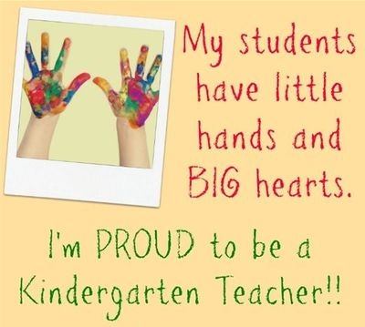
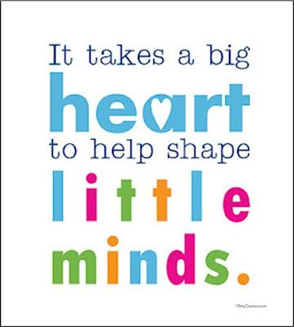

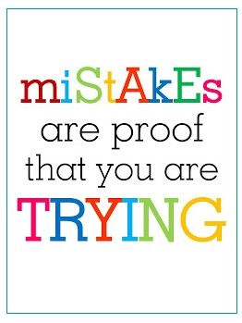
English In July Ch- 4 Helping and Sharing
Poem – The Little Plant Grammar -. Verbs, is/am/are, picture composition, Tenses, Go-goes, do-does, Application – Sick leave, Story Telling- The thirsty crow, Pronoun, Was/were
In Aug - Ch- 5 The Golden Bucket Poem – Pretending Grammar - Unseen Passage, Adjectives, Possession, Paragraph writing- My Mother
Maths In July – Unit -4 Addition , Unit -5 Subtraction,
Unit -6 Time and Calendar
In Aug - Unit -7 Money, Unit -8 Data Handling

EVS In July – Lesson -4 Living and Non-Living Things
Lesson – 5 Occupations , Early Human Beings
In August - Lesson- 6 All about Food

fgUnh tqykbZ & ikB & 4 bCucrwrk ]ikB & 5 xV: x/kk]
ikB & 6 ik;y dk lkgl] vuqPNsn & esjk fon~;ky;
O;kdj.k &o.kZ vkSj o.kZekyk] ek=k,W ‘kCn vkSj okD;] loZuke
vxLr & ikB & 7 ckny] ikB &8 bafM;k xsV]
O;dkj.k & izkFkZuk&i= & chekjh dh NqV~Vh ds fy, izkFkZuk & i=] ys[ku & gekjk jk”Vªh; i{kh & eksj

Reasoning In July – Alphabet Test, Patterns
In August - Rhyming Words

Computer In July – Ch-2 Parts of computer
Ch-3 How does a computer work?
In August - Ch-4 Operating a computer , Ch-5 More on Ms. Paint

Unit Test-2 Date sheet & syllabus
G.K. In July – On the move, Where are my things? India sport stars, Animal safari, Fishy facts, Knowing India

In August - To do, Word game, National leaders of India, Awesome animals!, Quiz Yourself 1, Musically yours, Story time, Shapes and Patterns, Useful plants

Date | Subject | Syllabus
29th July | Eng | Ch- 4 Helping and Sharing  Poem – The Little Plant Gr -. Verbs, is/am/are, picture composition, Application – Sick leave, Pronoun, Was/were
30th July | Hindi | ikB & 4 bCucrwrk ]ikB & 5 xV: x/kk] vuqPNsn & esjk fon~;ky;  O;kdj.k &o.kZ vkSj o.kZekyk] ek=k,W
31st July | Comp + G.K. | Ch-2,3  On the move, Where are my things? India sport stars, Animal safari, Fishy facts, Knowing India
01st Aug. | EVS | L -4 Living and Non-Living Things  L-5 Occupations, Early Human Beings
02 Aug. | Maths | Unit -4 Addition , Unit -5 Subtraction
03rd Aug. | Reas. | Alphabet Test, Patterns

Hindi: ikB & 5 xV: x/kk] ikB & 6 ik;y dk lkgl]
‘kCn vkSj okD;] loZuke
English – Ch-5 The Golden Bucket, Poem- Pretending, Adjectives, Possession
Maths: Unit –7 Money
EVS: Ch-6 All About Food
G.K. To do word game, National leaders of India, Awesome animals!

Reasoning - Rhyming Words

Comp - Ch-4 Operating a computer

Foundation Test Syllabus (Mini IIT)
27th Aug.,2019

Examination Policy
Dear Parent,
It is to inform you that there is a change in “Examination Policy” by RPS group of institution in which no re-examination will be conducted for U.Ts, Mid term and Finals for any case ABSENT will be marked in the report card. So you are requested not to make your ward absent on the day of exam.
- Medical case can be considered in case of emergency for that submission of medical certificate is required.

Date | Upcoming Events & Days for the Month of July
1st JULY | DOCTOR’S DAY
8TH JULY | ENG POEM RECITATION AUDITION(CLASS 1ST AND 2ND)
11TH JULY | ENGLISH CALLIGRAPHY COMPETITION
13TH JULY | ENG POEM RECITATION FINAL ROUND
18TH JULY | NELSON MANDELA DAY(SPEICAL ASSEMBLY)
26TH JULY  Communication Bites | KARGIL VIJAY DIWAS(SPECIAL ASSEMBLY)
Date | Upcoming Events & Days for the Month of AUG
1st AUG | PATRIOTIC SOLO SONG AUDITION(CLASS 1ST AND 2ND )
3RD AUG | TEEJ CELEBRATION
7TH AUG | PATRIOTIC SOLO SONG FINAL ROUND
8TH AUG | SENIOR CITIZEN DAY CELEBRATION
14TH AUG | RAKHI MAKING ACTIVITY
15TH AUG | INDEPENDENCE DAY CELEBRATION
23RD AUG | JANMASHTMI CELEBRATION
29TH AUG | INTER NATIONAL SPORTS DAY

2:00 | It’s two o’clock | 2:30 | It’s half past two.
2:05 | It’s five past two. | 2:35 | It’s twenty-five to three.
2:10 | It’s ten past two. | 2:40 | It’s twenty to three.
2:15 | It’s quarter past two. | 2:45 | It’s quarter to three.
2:20 | It’s twenty past two. | 2:50 | It’s ten to three.
2:25 | It’s twenty-five past two. | 2:55 | It’s five to three.
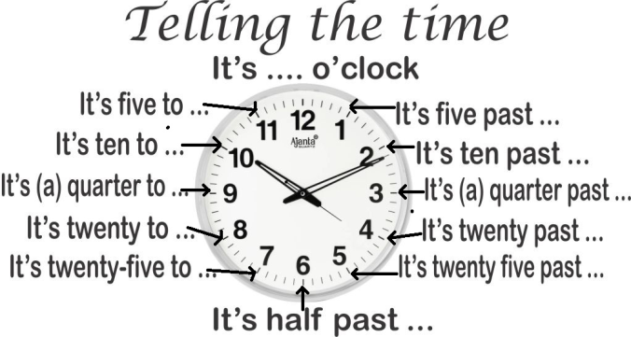

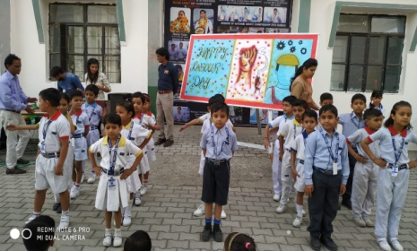
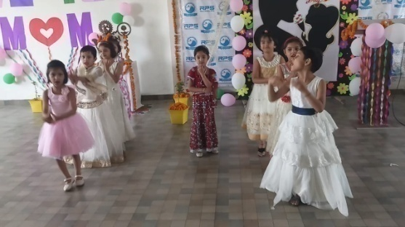

Baisakhi Celebration

WORLD HEALTH DAY
WE ARE GOING TO START WISHING TO OTHER WITH “PRANAM”
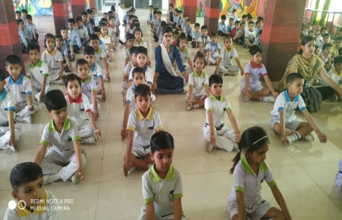

World Earth DAy

Mother’s Day

Labours day
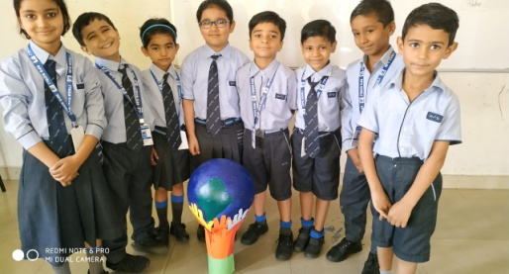

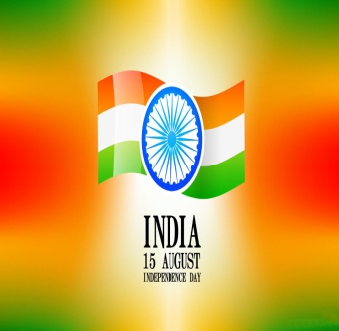
15th August:-Independence Day
Independence Day is annually celebrated on 15th August as red letter day in India on commemorating the nation struggle and immolation of our mighty freedom fighters. Every year on this day the Prime Minister addresses the nation from the ramparts of Red Fort.
11th July :-World Population Day
World Population Day is an annual event, observed on 11thJuly every year, which seeks to raise awareness of Global
population issues. The event was
established by the Governing Council of the United Nations Development
Programme in 1989.

25thJuly :-Women’s Equality Day
Women are treated as the Second Class Citizen in United State, nobody were allowed to vote Women, Women were not having full right in Govt. and Private jobs and institution. In the passage of 19th amendment of US constitution, Women got full rights everywhere.
17thJuly :-World Day for International Justice
World day for International Justice, also referred as day of International Criminal Justice or International justice day, is an international day celebrated throughout the world on 17th July as part of an effort to recognize the emerging system of International criminal justice.

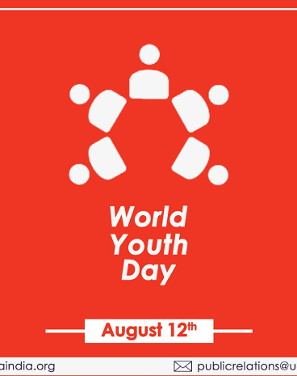
12th August:-International Youth Day
Youth is the Foundation of every Country. To Spread the awareness in Youth United Nation is celebrating International Youth Day on 12th August from 1999.
The Theme of IYD 2019 is Transforming Education.

18th July :-Nelson Mandela Day
Nelson Mandela International Day is an annual international day in honour of Nelson Mandela, celebrated each year on 18th July as Mandela’s birthday. The day was officially declared by the United Nations in November 2009, with the UN Mandela Day held on 18th July, 2010

19th August:- World Photography Day
World Photography Day is observed
worldwide on 19th of August every year
with a lot of zeal and enthusiasm.

29thJuly :-World Tiger Day
International Tiger Day is celebrated with the goal to promote a Global System for protecting the natural habitats of tigers in2010 at Sat Petersburg.

VOCAB PART
Sr.No | Word | Eng Meaning | Hindi Meaning
1 | Knight | Horseman | ?kqM+lokj
2 | Warrior | Fighter | ;ks/nk
3 | Chill | Cold | BaMk
4 | Warm | Hot | xeZ
5 | Abate | Reduce | de djuk
6 | Increase | Grow, rise | c<+uk
7 | Till | Explain | izdV djuk
8 | Think | Consider | le>uk
9 | Great | Powerful | egku
10 | Gross | Improper | vlaxr

VOCAB PART
Sr.No | Word | Eng Meaning | Hindi Meaning
21 | Danger | Harm | [krjk
22 | Dense | Thick | Bksl
23 | Famous | Renowned | izfl)
24 | Loud | Noisy | tksjnkj
25 | Mistake | Error | xyrh
26 | Quite | Silent | ‘kkar
27 | Old | Ancient | izkphu
28 | Busy | Engaged | O;Lr
29 | Destroy | Ruin | u”V djuk
30 | Idea | Thought | fopkj
VOCAB PART
Sr.No | Word | Eng Meaning | Hindi Meaning
11 | Smart | Clever | Pkykd
12 | Important | Essential | vko’;d
13 | Present | Gift | Migkj
14 | Story | Myth | dFkk
15 | Fat | Chubby | eksVk
16 | Simple | Easy | vklku
17 | Allow | Permit | vuqefr nsuk
18 | Begin | Start | vkjaHk djuk
19 | Complete | Finish | lekIr djuk
20 | Couch | Sofa | x|snkj iyax

Coordinator’s Sign. Head Mistress’s Sign. Principal’s Sign.

