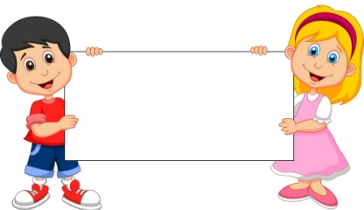
The Covenant
July& August

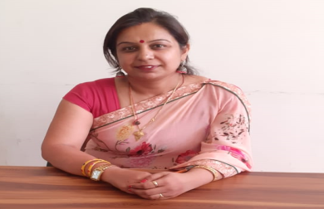
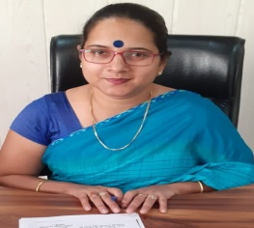
Dear Families,
Welcome to RPS Public School,
Kosli. RPS prides itself on being a
caring community of learners that
fosters pride in each student’s
developing abilities while
promoting social development.
We build the essence of community each day in every classroom touching all of our students. We know that no meaningful learning can happen unless students feel safe. We use the responsive classroom approach to teach children to act responsibly, take responsibility and to treat each other with respect.
Our teachers use a variety of innovative instructional approaches to instill a love of learning and build confident, competent students. We focus on enhancing student’s ability to think critically and creatively. We are fortunate to have a strong, active, parents teachers interacting ways and we encourage all parents to fully cooperate. I also urge you to take an active part in what your child required to do at home and to support independent reading.
There is a lot of information contained in the school website and more will come each month from our school newsletter. In addition you should always know that all of us at RPS believe in communication. We are here for your students and for you.
With Regards
Ms. Pankaj Yadav
Headmistress, RPS Kosli

Dear Families,
When there is focus on etiquette there is real intelligence, this would be the best mind as I consider it. The word “Sanskar” means process of increasing potential in ourselves and which is
a process by which positive qualities in man are developed and enhanced is known as a Sanskar. It makes the mind set of an individual of a specific type. As per the science of psychology, there is a strong relationship between the mind set the goal to be achieved. What RPS Kosli is trying to give them ambience to live with hostility so that they learn to fight for their right and against nonsense of society, live with encouragement, to inculcate in them confidence, to live with praise, so that they can learn appreciation, live with acceptance so they can love humanity, to live with approval so that they start liking themselves instead of copying others and lose their own ethics, to live with sharing so that they can learn generosity live with honesty so that they can learn truthfulness, to live with fairness so that they can learn justice , to learn to live with friendliness, they learn the World is a nice place in which to live. This relevant learning and living becomes all the more significant in today’s World when both the young and the old are on mindless pursuit of intellectual gains.

With Regards
Ms. Pooja Trilok Sharma
Principal, RPS Kosli

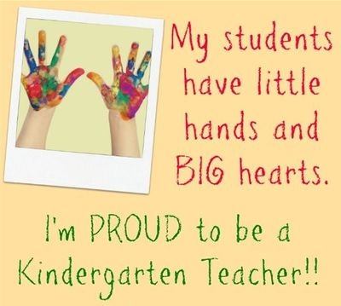

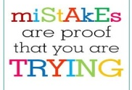
English In July – Ch-4(Bobby and Robby) Poem- On the bus
Gr.- Articles, This and That, Comprehension , Punctuation, WH Family, Paragraph Writing- My Best Friend
In August – Ch-5(What does the Prince want?) Poem- My
Garden
Gr. – Singular & Plural, Picture Composition, These and Those, Paragraph Writing- My Father, Nouns

Maths In July – Unit – 3, 4, Number Names- 51 to 80, Table 10 & 11, Addition and Subtraction
In August – Unit – 5 , Numbers name 51 to 100, Addition and Subtraction

EVS In July – Ch- 3 Home and Around , Ch- 4 My School, Good Manners
In August – Ch – 5 People who help us , Ch – 6 Food we eat ,
L-7 Clothes we wear

fgUnh tqykbZ & : # &xqV: dcwrj] Xkhr & edM+h jkuh ]gekjh cfx;k ds Qwy ], & “ksj dh ngkM+] ,s & eSuk mM+ xbZ] vks & rksrk vkSj eksj ] vkS & ykSdh dh csy] Xkhr & idkSM+h ] nl[kM+h fp=dFkk & ek¡ dh jlksbZ
O;kdj.k & Hkk’kk ] ek=k,¡ ] “kCn vkSj okD;] fyax]
,d & vusd ¼opu½]fnuksa ds uke]ifBr x|ka”k] vuqPNsn& ek¡
vxLr & ikB & 2 fcanq & panzfcanq] va & lafpr dh iarx ]v¡ vk¡ m¡ Å¡ & v¡ esys dh lSj] eSa & esjk ifjokj] ikB & 3 {k] =] K] J & la;qDrk{kj] ikB & 4 nks O;atu lkFk & lkFk] ikB & 10- bUgsa Hkh tkuksa
O;kdj.k & uke okys “kCn ¼laKk½ ] fxurh ] fp= o.kZu] vuqPNsn&esjk ifjokj ] esjk fç; fe=] ifBr x|ka’k

Reasoning In July – Body parts, Rhyming Words, Word Relationship
In August – Pick out the word, Missing Words, Coding Decoding

Computer In July – Ch- 2 and Ch- 3
In August – Ch- 4 and Ch- 5

G.K. In July – Life under Water, A chirpy Home, Domestic
Animals, Up in the sky, Means of Transport, Word , Game,
Food Habits of Animals
In August – Games we play, Spot the difference,
Traditional India Clothes, Quiz yourself 1,
Flower Delight Cartoon time, Festivals and Fun

Unit Test-2 Date sheet & syllabus
Date | Subject | Syllabus
29th July | Eng | L-3(Happy Birthday), Comprehension, Singular /Plural, Articles. Vocab
30th July | Hindi | ikB &’ksj dh ngkM] xqV: dcwrj] fnuksa ds uke] Qwyks ds uke] vuqPNsn & ekW
31st July | Comp + G.K. | L-2(A Machine), L-3(Uses of Computer)  Means of Transport, Word Game, National Symbol of India
01st Aug. | EVS | L-4(My School), L-5(People who help us)
02nd Aug. | Maths | Number names 51 to 70, Table 10 & 11, Unit -3 (Add & Subtraction)
03rd Aug. | Reas. | Pick out the Word,Missing Words, Rhyming Words, Bodyparts

Hindi: rksrk vkSj eksj] ykSdh dh csy] eSuk mM+ xbZ] fxurh] laKk] fyax vkSj opu
English – Ch-4(Bobby and Robby), This/that, These/ Those, Nouns

Maths: Unit – 4 Numbers Name – 51 to 100, Table 9 and 10, Unit -5 (More Addition and Subtraction)
EVS: Ch-5 People who help us, Ch-6 Food we eat
G.K. Domestic, Animals, Good Manners and Bad Manners, Life under water, Games we play
Reasoning - Pick out the word, Coding - Decoding
Comp - Ch-4 Parts of computer

Foundation Test Syllabus (Mini IIT)
27th AUG,2019

Examination Policy
Dear Parent,
It is to inform you that there is a change in “Examination Policy” by RPS group of institution in which no re-examination will be conducted for U.Ts, Mid term and Finals for any case ABSENT will be marked in the report card. So you are requested not to make your ward absent on the day of exam.
- Medical case can be considered in case of emergency for that submission of medical certificate is required.

Date | Upcoming Events & Days for the Month of July
1st JULY | DOCTOR’S DAY
8TH JULY | ENG POEM RECITATION AUDITION(CLASS 1ST AND 2ND)
11TH JULY | ENGLISH CALLIGRAPHY COMPETITION
13TH JULY | ENG POEM RECITATION FINAL ROUND
18TH JULY | NELSON MANDELA DAY(SPEICAL ASSEMBLY)
26TH JULY  Communication Bites | KARGIL VIJAY DIWAS(SPECIAL ASSEMBLY)
Date | Upcoming Events & Days for the Month of AUG
1st AUG | PATRIOTIC SOLO SONG AUDITION(CLASS 1ST AND 2ND )
3RD AUG | TEEJ CELEBRATION
7TH AUG | PATRIOTIC SOLO SONG FINAL ROUND
8TH AUG | SENIOR CITIZEN DAY CELEBRATION
14TH AUG | RAKHI MAKING ACTIVITY
15TH AUG | INDEPENDENCE DAY CELEBRATION
23RD AUG | JANMASHTMI CELEBRATION
29TH AUG | INTER NATIONAL SPORTS DAY

2:00 | It’s two o’clock | 2:30 | It’s half past two.
2:05 | It’s five past two. | 2:35 | It’s twenty-five to three.
2:10 | It’s ten past two. | 2:40 | It’s twenty to three.
2:15 | It’s quarter past two. | 2:45 | It’s quarter to three.
2:20 | It’s twenty past two. | 2:50 | It’s ten to three.
2:25 | It’s twenty-five past two. | 2:55 | It’s five to three.
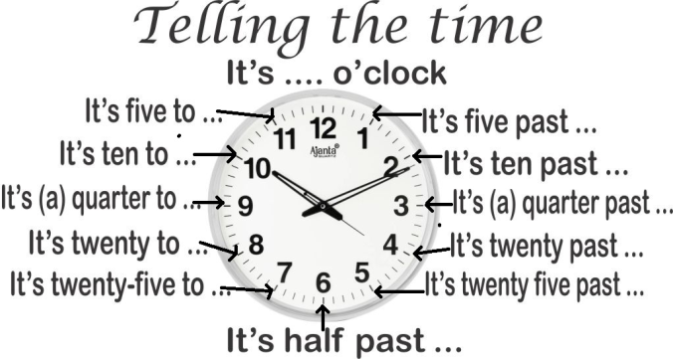

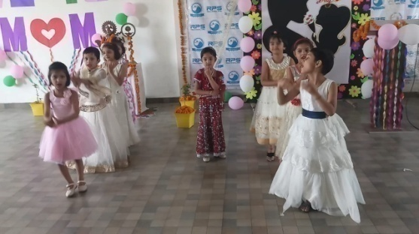
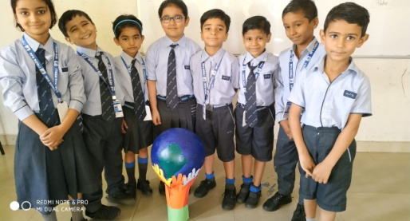

Baisakhi Celebration

WORLD HEALTH DAY
WE ARE GOING TO START WISHING TO OTHER WITH “PRANAM”
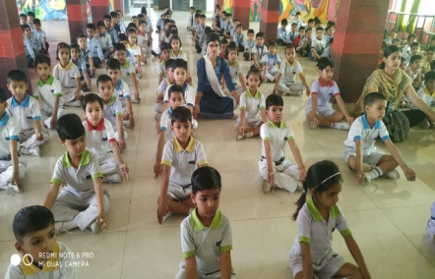

Labours day

World Earth DAy

Mother’s Day
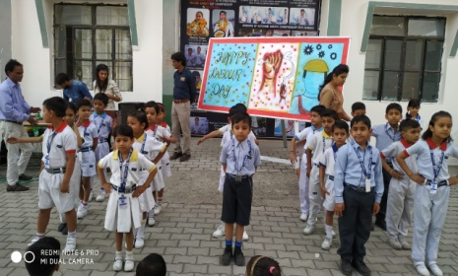

15th August:-Independence Day
Independence Day is annually celebrated on 15th August as red letter day in India on commemorating the nation struggle and immolation of our mighty freedom fighters. Every year on this day the Prime Minister addresses the nation from the ramparts of Red Fort.
11th July :-World Population Day
World Population Day is an annual event, observed on 11thJuly every year, which seeks to raise awareness of Global
population issues. The event was
established by the Governing Council of the United Nations Development
Programme in 1989.

25thJuly :-Women’s Equality Day
Women are treated as the Second Class Citizen in United State, nobody were allowed to vote Women, Women were not having full right in Govt. and Private jobs and institution. In the passage of 19th amendment of US constitution, Women got full rights everywhere.
17thJuly :-World Day for International Justice
World day for International Justice, also referred as day of International Criminal Justice or International justice day, is an international day celebrated throughout the world on 17th July as part of an effort to recognize the emerging system of International criminal justice.

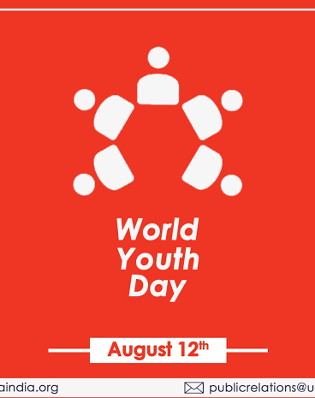
12th August:-International Youth Day
Youth is the Foundation of every Country. To Spread the awareness in Youth United Nation is celebrating International Youth Day on 12th August from 1999.
The Theme of IYD 2019 is Transforming Education.

18th July :-Nelson Mandela Day
Nelson Mandela International Day is an annual international day in honour of Nelson Mandela, celebrated each year on 18th July as Mandela’s birthday. The day was officially declared by the United Nations in November 2009, with the UN Mandela Day held on 18th July, 2010

29thJuly :-World Tiger Day
International Tiger Day is
celebrated with the goal to promote
a Global System for protecting the
natural habitats of tigers in2010
at Sat Petersburg.

29thJuly :-World Tiger Day
International Tiger Day is celebrated with the goal to promote a Global System for protecting the natural habitats of tigers in2010 at Sat Petersburg.

VOCAB PART
Sr.No | Word | Eng Meaning | Hindi Meaning
1 | Knight | Horseman | ?kqM+lokj
2 | Warrior | Fighter | ;ks/nk
3 | Chill | Cold | BaMk
4 | Warm | Hot | xeZ
5 | Abate | Reduce | de djuk
6 | Increase | Grow, rise | c<+uk
7 | Till | Explain | izdV djuk
8 | Think | Consider | le>uk
9 | Great | Powerful | egku
10 | Gross | Improper | vlaxr

VOCAB PART
Sr.No | Word | Eng Meaning | Hindi Meaning
11 | Smart | Clever | Pkykd
12 | Important | Essential | vko’;d
13 | Present | Gift | Migkj
14 | Story | Myth | dFkk
15 | Fat | Chubby | eksVk
16 | Simple | Easy | vklku
17 | Allow | Permit | vuqefr nsuk
18 | Begin | Start | vkjaHk djuk
19 | Complete | Finish | lekIr djuk
20 | Couch | Sofa | x|snkj iyax
VOCAB PART
Sr.No | Word | Eng Meaning | Hindi Meaning
21 | Danger | Harm | [krjk
22 | Dense | Thick | Bksl
23 | Famous | Renowned | izfl)
24 | Loud | Noisy | tksjnkj
25 | Mistake | Error | Xyrh
26 | Quite | Silent | ‘kkar
27 | Old | Ancient | izkphu
28 | Busy | Engaged | O;Lr
29 | Destroy | Ruin | u”V djuk
30 | Idea | Thought | fopkj

Coordinator’s Sign. Head Mistress’s Sign. Principal’s Sign.

