­­



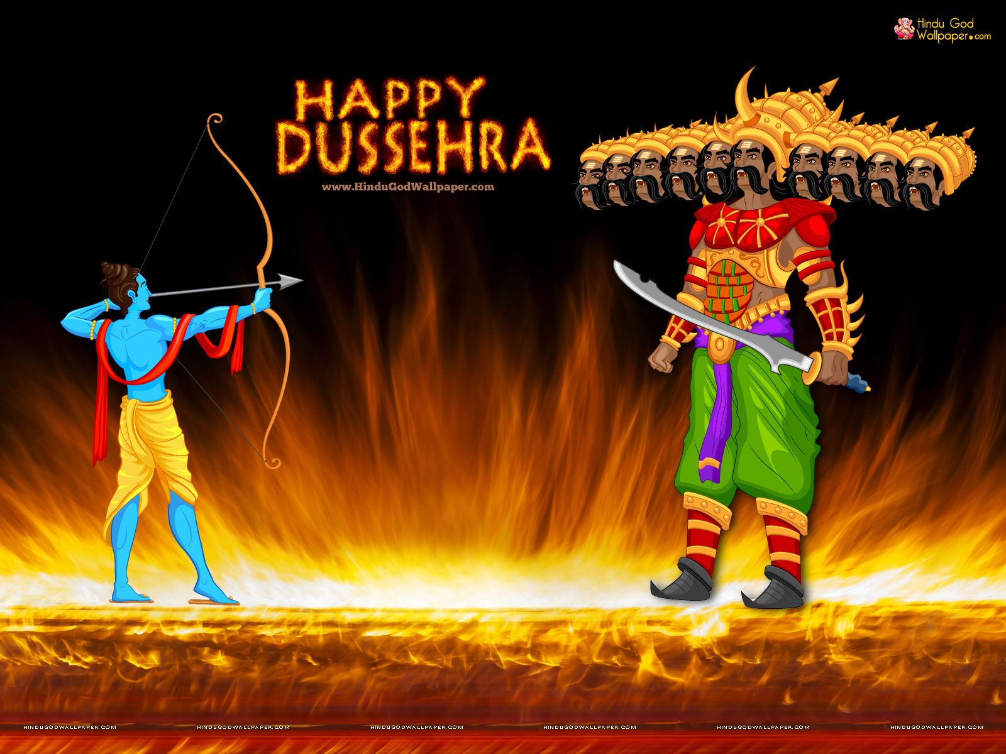 

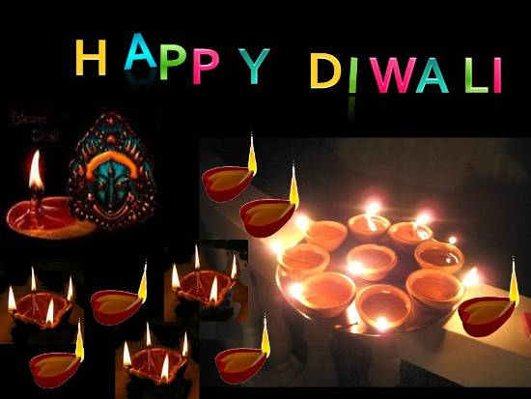



***“Diwali” The Festival of Lights***

**Student Name _____________________**

**Integrity: Join your soul to your role.**

It is the choice between what’s convenient and what’s right. It is the practice of being honest and showing a consistent and uncompromising adherence to strong moral and ethical principles and values.

There are three constant in life-change, choice and principle.

We must adjust to the changing times and still hold to unchanging principles. Integrity is the seed for achievement. It never fails. History states that principled leaders solved moral problems. They had courage to act rightly.

Be impeceable with your words. Speak with integrity say only what you mean. Avoid using words against anyone or to gossip about others.

Walk with honour, character and integrity in all that you do. Do these things and you will find that you can appreciate the adventure of life and live with great ease.

Dear students, you must understand that the wind might cause a kite to rise but what keeps it up there is the fact that somebody on the ground has a steady hand. You have to hold steady to your values-your integrity. It’s your anchor.

Sometimes, it takes courage to join soul and role in an environment that makes it unsafe to show up with integrity and act in alignment with it. But when we find that courage, our lives become more whole, our work reaches deeper and people we serve are better served and the world becomes a better place.

Live your life so that when your friends and family think of fairness, care and integrity, they think of you.

­



Your 1-Term exams are over and all of you might be waiting for the results. Your results are expected to be announced in the 2nd week of October. I hope you have given your best and your result will be outstanding.

To add more cheers and happiness to life, this month is coming as festive month. Dear students all of us wish to live a happy and healthy life. We are a part of environment. We eat in it, breathe in it & live in it. All these interactions shape our world.On this 150th Gandhi Jayanti our government has flagged the discouraging of SUP (Single use plastic).

All of us ought to give our contribution to this campaign. Your little hands can do wonders if you approach positively towards it.

This Diwali light a diya to your determination, to spread awareness to discourage SUP. Diwali is the day to light diyas and mouth full of sweets.

It is our duty to celebrate ecofriendly Diwali by saying no to crackers. Buy clay diyas made by local people. May this Diwali double your pleasures in future!

Wish you all a clean, green and safe Diwali !

Syllabus for Foundation Test Series Minor Test – 5 (30.09.2019)

Important Days and Dates

**Festival Season in full swing:**

**Navratri:** It is nine night festival that celebrates the mother goddess or shakti in all her manifestations including Durga, Lakshmi and Saraswati worship and fasting take place in day time while nights are reserved for making fun and dancing.

**Dussehra:**Navratri culminates with Dussehra. It widely commemorates the defeat of demon king Ravana by Lord Ram. Huge effigies of Ravan go up in smoke all over and thus give a message the victory of good over evil.

**Diwali:**This festival is celebrated by lightening traditional eartherndiyas and decorate houses with colourfulrangoli. It is marked by large firework display. On this day home are cleaned and new clothes are worn.

**Guru Nanak Jayanti:** This festival celebrates the b’day of Guru Nanak Ji. On this occasion the golden temple in Amritsar is decorated with numerous lights. A holy book is taken in procession out of the temple.

**RannUtsav Kutch:** This is the version of desert carnival that take place in kutch of Gujrat. Days are filled with dance, folk music and handicraft stalls. This carnival takes place in the great Rann salt desert of kutch.

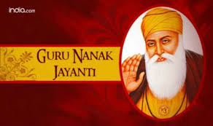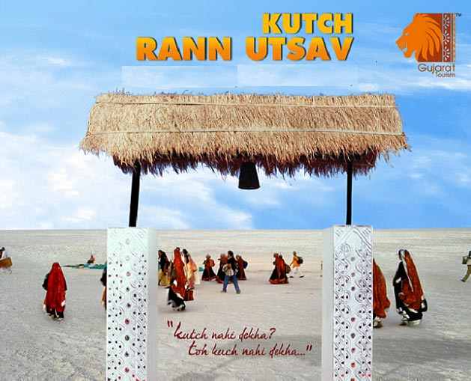



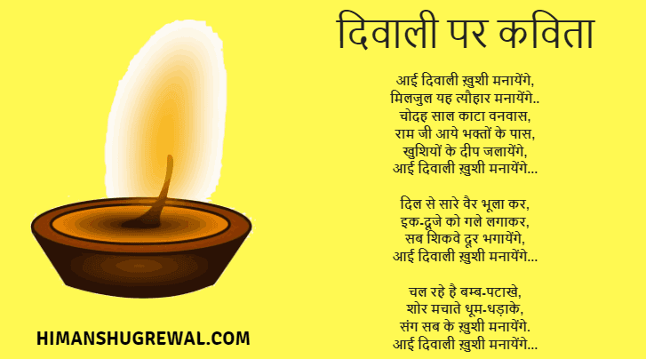

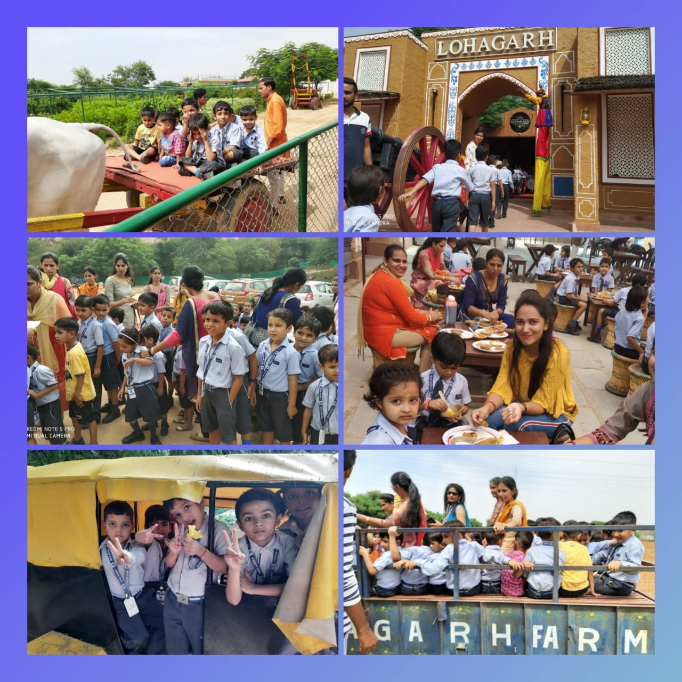

**EVS**

**Book no. 4 & 5**

* Seasons’ name, Bird’s name, Transport’s’ name, Times of a day, Flowers’ name, Animal’s and their young, Sound of animals, Homes of animals.

**Stories Name**

* **Umbro the umbrella bird**
* **The monkey and the cats**

**Rhymes**

* **Wonderful vegetables**
* **Moo-Moo says the cow**
* **The Zoo is lots of fun**
* **My Garden**

**Activities**

**Book no.4 – Pg.no. 117 to 130**

**Book no. 5 – Pg.no. 127 to 138**

**Stories & Rhymes**

**Book no. 4 – Pg. no. 100 to 114**

**Book no. 5 – Pg .no. 108 to 124**

**Maths**

**Book no. 4 & 5**

Number name 1 to 20, skip counting, Ascending/Descending, One/Many, shape – Cube, Numbers 101 to 200, Table of 6.

**Hindi**

**iqLrddk;Z**&ist+ ua0 15 ls 30 rd A lfCt;ksa ds uke ] fnuksa ds uke]nks ] rhu ] pkj v{kjksa ds ‘kCnAeghuksa ds uke] foykse ‘kCnek=k,W&vk ] b] bZ ] m ] Å ] Jqrys[kA

**Activity Corner**

**English**

**Book no. 4 & 5**

Sound of vowel ‘u’ – Ub, Ug, Un, Up, Us, Ut, Opposite words, Change the number, Cluster words- Sound of vowel ‘i' – im, ip, it, ix. Sound of vowel ‘o’ – ob, og,op, ot, ox, oy

**Syllabus Corner**

**Month of Oct & Nov.**



**Co-coordinator’s Sign Headmistress’s Sign Principal’s Sign**

**Oct 1 : Grand Parents Day**

**Oct 2 : Gandhi Jayanti International**

**Day of non violence**

**Oct 4 : World Animal Day**

**Oct 5 : World Teacher’s Day**

**Oct 6 : World Wildlife Day**

**Oct 8 : Indian Airforce Day**

**Oct 10 : Indian Postal Day**

**Oct 11 : National Girl Child Day**

**Oct 12 : World Sight Day**

**Oct 15 : World Students Day**

**Oct 16 : World Food Day**

**Oct 24 : United Nation Day**

**Oct 31 : National Unity Day**

**Nov 1 : Haryana Day**

**Nov 5 : World Tsunami Day**

**Nov 7: National Cancer Awareness Day**

**Nov 12: GurunanakJayanti**

**Nov 14: Childern’s Day**

**Nov 21 : World Television day**

**Nov 26: Indian Constitution Day**

**Nov 30. Flag Day**

**DAYS TO CELEBRATE OCTOBER2019 DAYS TO CELEBRATE NOVEMBER 2019**

**November 2019**

**1st Nov - Haryana Day (Ramp Walk) Theme is**

**Haryana personalities**

**6th Nov. Show & Tell Competition of Class U.K.G.**

**7th Nov. Show & Tell Competition of Class L.K.G.**

**14th Nov. Children’s Day Celebration**

**30th Nov. Blue Day Celebration + B’day**

**Celebration**

**October 2019**

**9th Oct – World Post Day(Activity Show Post card**

**in the class and tell about benefits of**

**post office)**

**16th Oct – World Food Day (Healthy Food**

**Competition)**

**19th Oct – Story Telling Competition of Class**

**U.K.G.**

**22nd Oct – Story Telling Competition of Class**

**L.K.G.**

**25th Oct – Card Making for Diwali Celebration**

**31st Oct – Halloween Day + Orange Day**

**Celebration + B’Day Celebration**

|  |  |  |  |
| --- | --- | --- | --- |
| Date | Day | Subject | Syllabus |
| 15-11-19 | Friday | Hindi | **2]3]4 v{kjks ds ‘kCn A ek=k,W&bZ ] m] ÅA lfCt;ksa ds uke] fnuks ds uke] eghuksa ds uke] foykse ‘kCnA** |
| 16-11-19 | Saturday | Maths | Numbers 101-200, Numbers name 1 to 20, Skip counting, One-Many, Ascending-Descending, Table of 6 and Book 4,5 |
| 18-11-19 | Monday | English | Book 4,5 cluster word – im, ix, ig, ot, ox, ug, oy, ut, us, opposites word, Change the numbers |
| 19-11-19 | Tuesday | EVS | Book4,5 , Seasons, Birds, transport, Flower’s name, Animal’s Name and their young sound of animals, Home of animals. |

**UNIT TEST 3**

**Science**

Ch.9 Ratio and Proportion

Ch.10 Data Handling

Physics

Ch.13 Electricity & Circuits

Chemistry

Ch.6 Changes Around Us

Biology

Ch.8 Habitat of the living things

**Reasoning**

Ch. 8 Mathematical Operations (V)

Ch. 9 Analytical Reasoning (N.V)

**History**

Ch-8 Ashoka, The Emperor who gave upwar.

Ch-9 Vital Villages, Thriving Towns,

Geography

Ch-5 Major Domains of the Earth

Civics

Ch-5 Panchayati Raj

**G.K**

* Book Pg. No. 52 to 65
* Current Affairs

Books & their Authors