­­

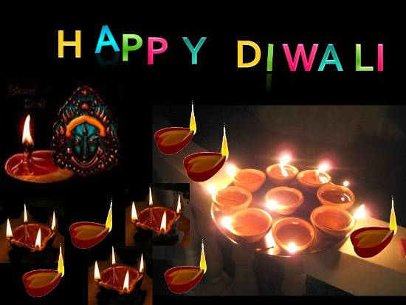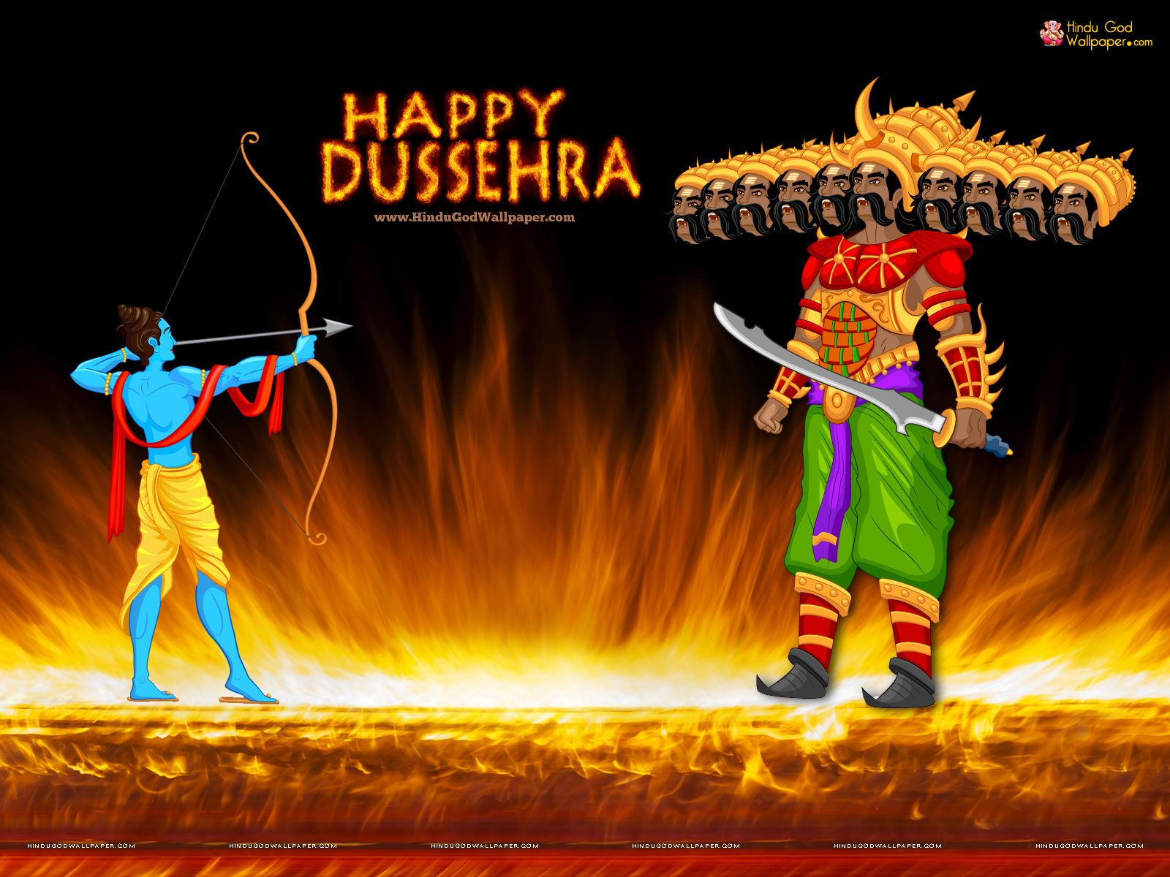

***“Diwali” The Festival of Lights***

**Student Name _____________________**

**Integrity: Join your soul to your role.**

It is the choice between what’s convenient and what’s right. It is the practice of being honest and showing a consistent and uncompromising adherence to strong moral and ethical principles and values.

There are three constant in life-change, choice and principle.

We must adjust to the changing times and still hold to unchanging principles. Integrity is the seed for achievement. It never fails. History states that principled leaders solved moral problems. They had courage to act rightly.

Be impeceable with your words. Speak with integrity say only what you mean. Avoid using words against anyone or to gossip about others.

Walk with honour, character and integrity in all that you do. Do these things and you will find that you can appreciate the adventure of life and live with great ease.

Dear students, you must understand that the wind might cause a kite to rise but what keeps it up there is the fact that somebody on the ground has a steady hand. You have to hold steady to your values-your integrity. It’s your anchor.

Sometimes, it takes courage to join soul and role in an environment that makes it unsafe to show up with integrity and act in alignment with it. But when we find that courage, our lives become more whole, our work reaches deeper and people we serve are better served and the world becomes a better place.

Live your life so that when your friends and family think of fairness, care and integrity, they think of you.

­



Your 1-Term exams are over and all of you might be waiting for the results. Your results are expected to be announced in the 2nd week of October. I hope you have given your best and your result will be outstanding.

To add more cheers and happiness to life, this month is coming as festive month. Dear students all of us wish to live a happy and healthy life. We are a part of environment. We eat in it, breathe in it & live in it. All these interactions shape our world. On this 150th Gandhi Jayanti our government has flagged the discouraging of SUP (Single use plastic).

All of us ought to give our contribution to this campaign. Your little hands can do wonders if you approach positively towards it.

This Diwali light a diya to your determination, to spread awareness to discourage SUP. Diwali is the day to light diyas and mouth full of sweets.

It is our duty to celebrate ecofriendly Diwali by saying no to crackers. Buy clay diyas made by local people. May this Diwali double your pleasures in future!

Wish you all a clean, green and safe Diwali !

Syllabus for Foundation Test Series Minor Test – 5 (30.09.2019)

Important Days and Dates

**Festival Season in full swing:**

**Navratri:** It is nine night festival that celebrates the mother goddess or shakti in all her manifestations including Durga, Lakshmi and Saraswati worship and fasting take place in day time while nights are reserved for making fun and dancing.

**Dussehra:** Navratri culminates with Dussehra. It widely commemorates the defeat of demon king Ravana by Lord Ram. Huge effigies of Ravan go up in smoke all over and thus give a message the victory of good over evil.

**Diwali:** This festival is celebrated by lightening traditional earthen diyas and decorate houses with colourful rangoli. It is marked by large firework display. On this day home are cleaned and new clothes are worn.

**Guru Nanak Jayanti:** This festival celebrates the b’day of Guru Nanak Ji. On this occasion the golden temple in Amritsar is decorated with numerous lights. A holy book is taken in procession out of the temple.

**Rann Utsav Kutch:** This is the version of desert carnival that take place in kutch of Gujrat. Days are filled with dance, folk music and handicraft stalls. This carnival takes place in the great Rann salt desert of kutch.

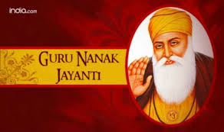 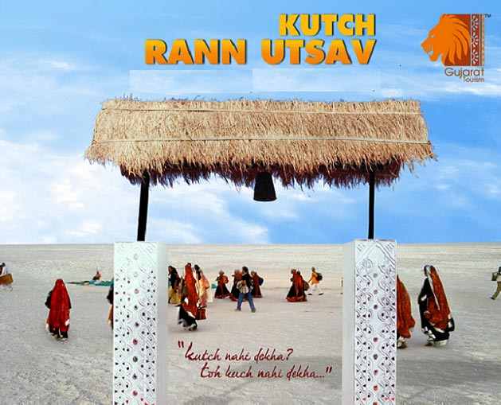



**English**

**(Oct.) Grammar -**  Uses of has & have, Paragraph – Peacock, Picture composition, Comprehension,

Position words.

**Book** – Ch-6(Arun and Tara), Ch-7 Clever Fred

**(Nov.) Grammar -** Pronouns, Comprehension, Description words, Paragraph – My Pet,

**Book** – Poem – Mice are Nice, Ch-8 Free and happy, Ch-9 Dear animal day, Poem- A little bird’s

Song.

**EVS**

**Oct.** – Ch-8 (weathers & Seasons), Ch-9 (air)

**Nov.** – Ch-10(drops of water), Ch-11 (Our

Green Friends), Religious festival of

India.

**Maths**

**Oct.** – Unit- 10 Shapes, number

names – 101 to 150, Table 2 to 10,

Unit-7 (Money)

**Nov.** – Unit-6 Multiplication, Unit-9 Time,

Unit-8 Measurement

**Hindi**

**vDVwcj O;kdj.k % & loZuke ] foykse ‘kCn ] lekukFkhZ ‘kCn ] vuqPNsn & fnokyh] vifBr x|ka’k] eghuks ds uke**

**xqatu % & vW ] vkW] mW] ÅW & esys dh lSj] esjk ifjokj] la;qDrk{kj] nks O;atu] lkFk& lkFk ]ikB&10¼bUgsa Hkh tkuksa ½]**

**/ofu;ksa ds fpg~u ] vkvks fxusa] i<+us dh ckj] xhe & gkFkhA**

**uoacj & O;kdj.k & fo’ks”k.k] fdz;k] vifBr x|ka’k] vuqPNsn& esjk ifjp;] chekjh ds fy, izkFkZuk & i=**

**xqatu & j ds cgqr ls :i] dfork & cj[kk jkuh] eSa fdlh dks ugh ekW:xk] ikB& 8 fp= o.kZu ] ikB&9 i<+us**

**dh ckjh] MkDWVj ftjkQ+**

**Syllabus of Oct. & Nov. Months**

**G.K.**

**Oct.** Amazing Animals, A walk through Nature, World game, Signs that speak, Around India, Guessing countries, Different Land forms

**Nov.** Music makes, To do, Day by Day, Cinemagic, Famous Indians, Famous leaders of the World, Story time

**Reasoning**

**Oct.** – Compound Word, Relationship, Missing links

**Nov. –** World Relationship with pictures, Pairs, Analogy(sentence)

**Computer**

**Oct.** – L-5 The Keyboard, L-6 Using a mouse

**Nov.** L-7 Data and Memory, L-8 Storage in a computer

**Syllabus of Objective Test (30.10.2019)**

Eng - Ch-6 Arun and Tara ,

Gr – Uses of has / have

Hindi - **loZuke] esys dh lSj**

EVS - Ch-8 (Weathers & Seasons)

Maths - Unit- 10 (Shapes)

G.K. - Amazing Animals, Signs that speak

Reas - Compound Word

Comp - Ch- 5 The Keyboard



**Dear Parent**

**PTM will be held on 13th Oct.019(Sunday) from 9:00A.M. to 12:00 Noon**

**Nov 1 : Haryana Day**

**Nov 5 : World Tsunami Day**

**Nov 7 : National Cancer Awareness Day**

**Nov 12: Gurunanak Jayanti**

**Nov 14: Children’s Day**

**Nov 21 : World Television day**

**Nov 26: Indian Constitution Day**

**Nov 30. Flag Day**

**DAYS TO CELEBRATE OCTOBER 2019 DAYS TO CELEBRATE NOVEMBER 2019**

**Oct 1 : Grand Parents Day**

**Oct 2 : Gandhi Jayanti International**

**Day of non violence**

**Oct 4 : World Animal Day**

**Oct 5 : World Teacher’s Day**

**Oct 6 : World Wildlife Day**

**Oct 8 : Indian Airforce Day**

**Oct 10 : Indian Postal Day**

**Oct 11 : National Girl Child Day**

**Oct 12 : World Sight Day**

**Oct 15 : World Students Day**

**Oct 16 : World Food Day**

**Oct 24 : United Nation Day**

**Oct 31 : National Unity Day**

**November 2019**

**1st Nov – Haryana Day(Ramp Walk) Theme is Haryana**

**Personalities**

**9th Nov – EVS Quiz**

**12th Nov – Gurunanak Jayanti**

**(Skit Prepare by class 1st Students)**

**14th Nov – Children’s Day (Special Assembly)**

**20th Nov – Child Rights Day(Skit Prepare by class 2nd**

**Students)**

**30th Nov - Flag Day (Tell the students about the**

**importance of Flag)**

**October 2019**

**09th Oct – World Post Day(Activity Show Post Card in**

**the class and tell about benefits of Post Office)**

**11th Oct – Candle and Candle Stand Decoration**

**Competition section wise**

**16th Oct – World Food Day(Healthy Food Competition)**

**19th Oct – Spell Bee First Round**

**23rd Oct – Final Round of Spell Bee(House wise)**

**25th Oct – Diwali Celebration**

**30th Oct – World Saving Day(Tell about the importance**

**of Piggy Bank + Saving money)**

**31st Oct – National Unity Day(Special Assembly)**

|  |  |  |  |
| --- | --- | --- | --- |
| Date | Day | Subject | Syllabus |
| 14-11-19 | Thursday | Reasoning | Compound words, Relationship |
| 15-11-19 | Friday | Hindi | la;qDrk{kj ds “kCn ] eSa fdlh dks ugha ekW:xk] esys dh lSj |
| 16-11-19 | Saturday | Maths | Unit-7 Money, Number Names-101 to 120, Unit- Shapes |
| 18-11-19 | Monday | English | Ch-7 Clever Fred, Position Word, Uses of Has/ Have |
| 19-11-19 | Tuesday | Computer | Ch-5 Operating a Computer |
| 22-11-19 | Friday | EVS | Ch-9 Air |
| 23-11-19 | Saturday | G.K. | Amazing animals, A walk through nature, Signs that Speak |
|  |  |  |  |

**UNIT TEST 3**

**Science**

Ch.9 Ratio and Proportion

Ch.10 Data Handling

Physics

Ch.13 Electricity & Circuits

Chemistry

Ch.6 Changes Around Us

Biology

Ch.8 Habitat of the living things

**Reasoning**

Ch. 8 Mathematical Operations (V)

Ch. 9 Analytical Reasoning (N.V)

**History**

Ch-8 Ashoka, The Emperor who gave upwar.

Ch-9 Vital Villages, Thriving Towns,

Geography

Ch-5 Major Domains of the Earth

Civics

Ch-5 Panchayati Raj

**G.K**

* Book Pg. No. 52 to 65
* Current Affairs

Books & their Authors

Co-ordinator’s Sign Headmistress’s Sign Principal