Department | PHYSICS
Session | 2023-2024

Activity Name | Farewell - 2024
Short summary | The “BOSE SOCIETY”, Department of Physics, RPS Degree College, Balana, Mahendergarh, Haryana has organized” Farewell cum Facilitation Program -2024” for B.Sc. Hons. Physics and M.Sc. Physics of Final year on 22th April, 2024 for the Session 2023-24.  Mr. and Ms. Farewell: Mr. Nikhil (21HP10) and Ms. Nikita (21HP03) Hons. Physics 2021-2024  Mr. and Ms. Farewell: Mr. Nitin Kaushik (22PHY27) and Ms. Pinki (22PHY25) M.Sc. Physics 2022-2024  .

Photo 1 | 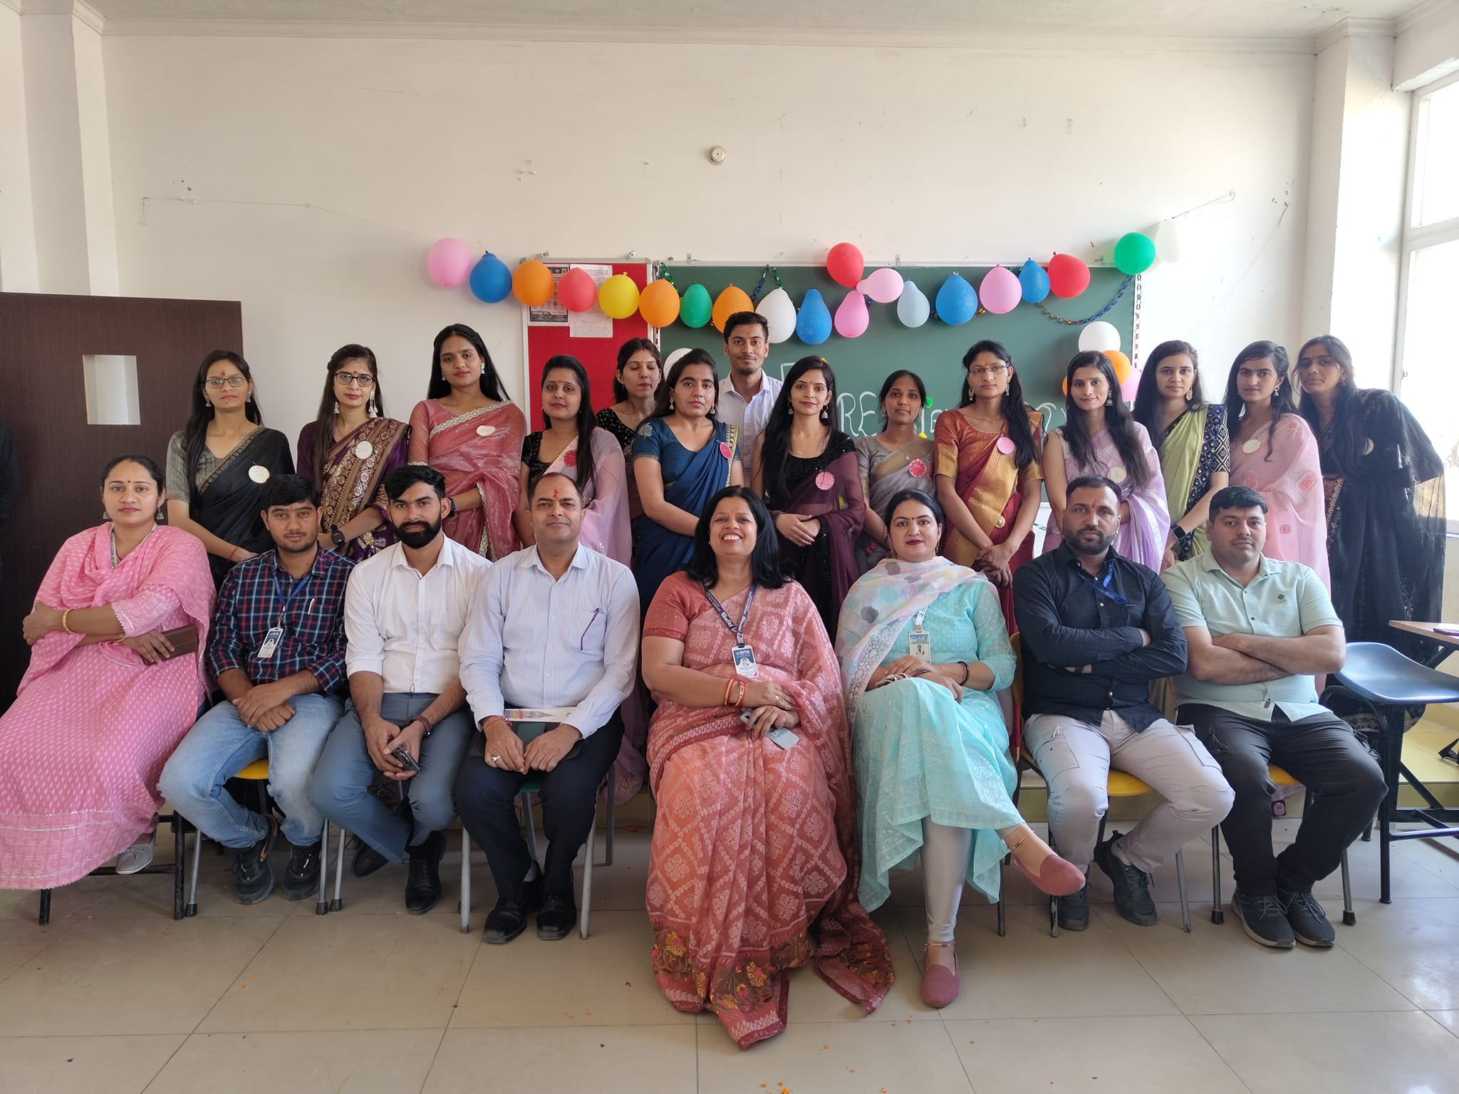
Photo 2 | 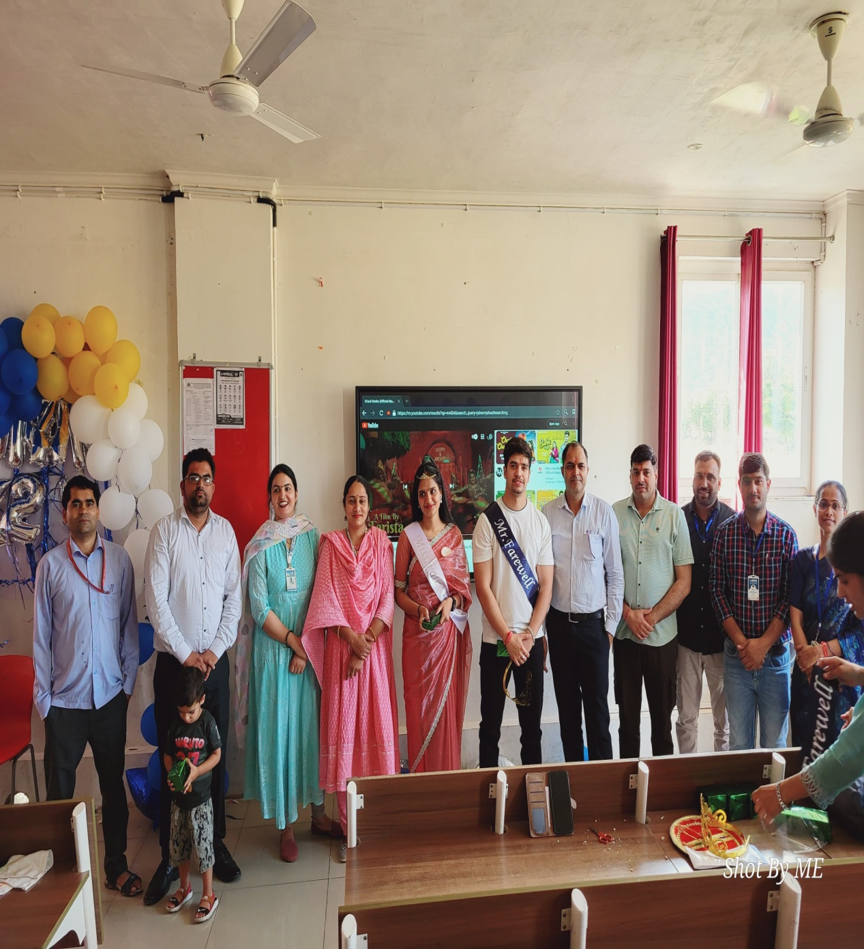

Photo 3 | 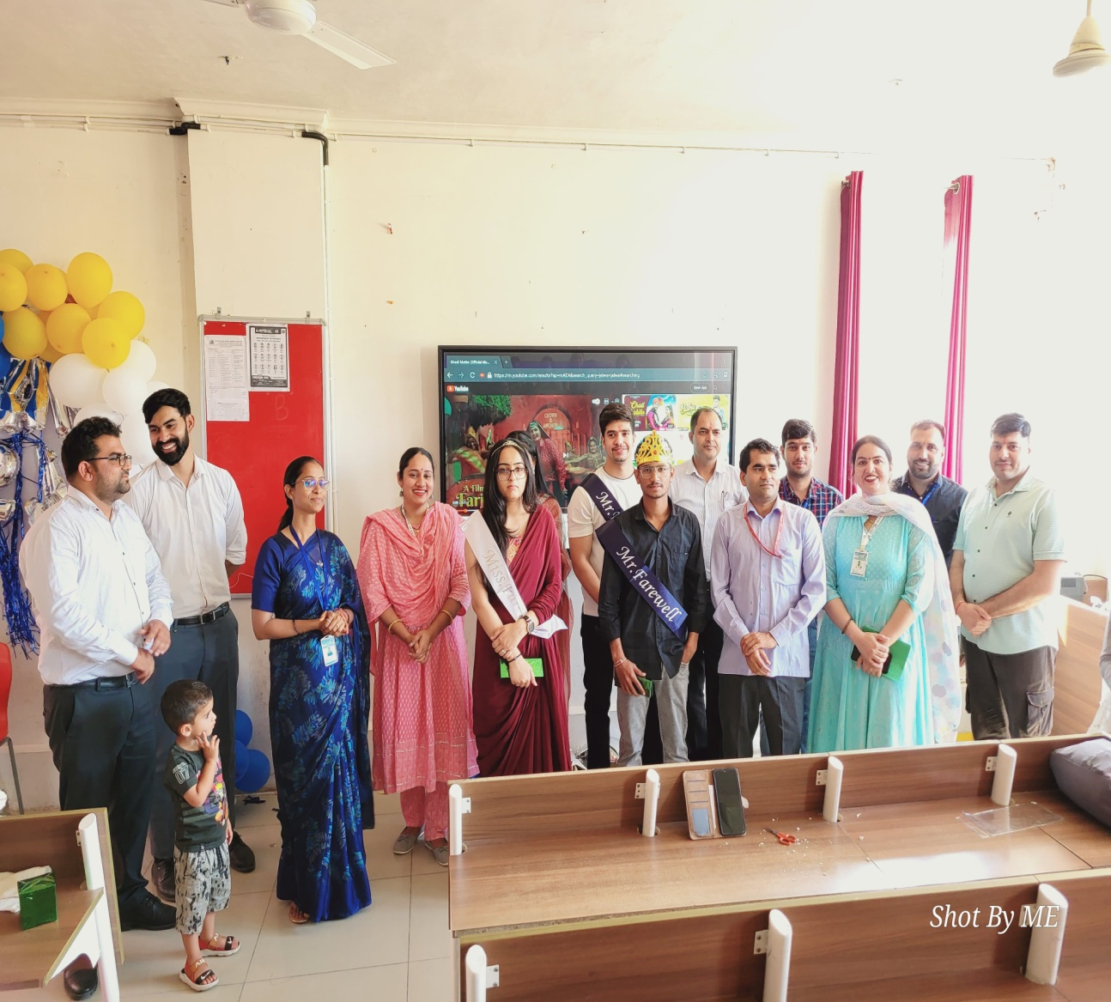

Photo 4 | 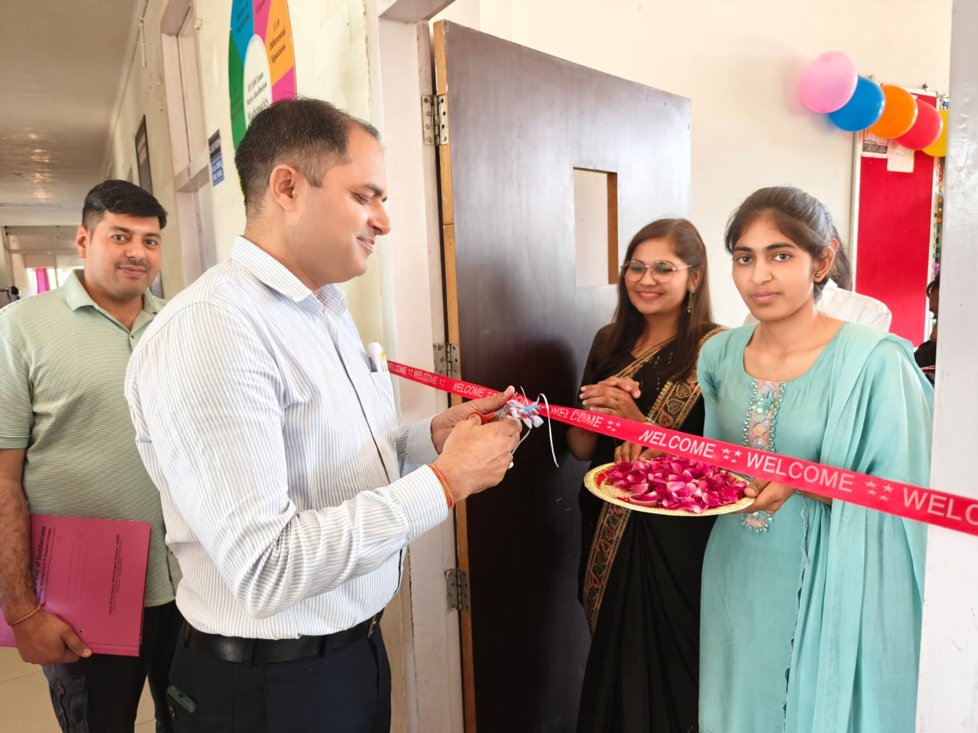

Photo 5 | 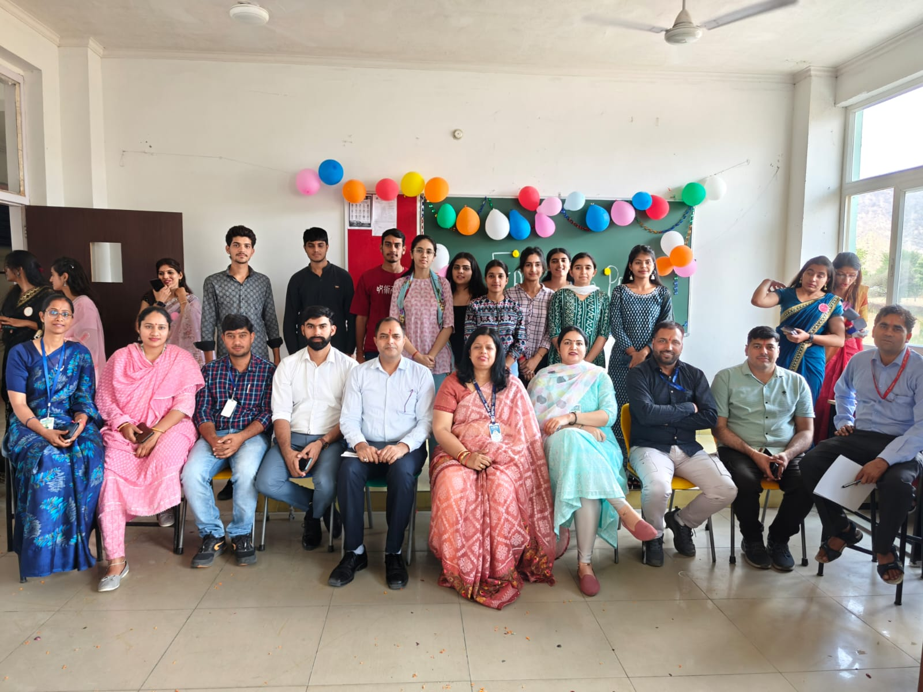

Photo 6 | 