Department | PHYSICS
Session | 2023-2024

Activity Name | Basant Utsav - 2024
Short summary | Department of Physics, RPS Degree College, Balana, Mahendergarh has successfully celebrated the “Basant Utsav-2024” under the aegis of IQAC on 14 February, 2024.  For this occasion, a “Hawan Pujan” was done by our M.Sc. Physics students (Nitin Kaushik, Rahul and Tarun) to take the blessings of Ma Saraswati.  Dr. Mahesh Kumar Yadav, Director, RPS Group of Institutions along with Dr. Davender Singh, Principal, RPS Degree College also joined the Ma Saraswati Pujan. Including M.Sc. Physics, B.Sc. Honours Physics and B.Sc. non medical students around 100 students along with faculty of Department of Physics and other departments also fused in this event.  After the completion of Ma Saraswati Pujan, “Prashad” was distributed by our student volunteers. Students also presented a cultural dance performance and shared the deep meaning behind the Celebration of “Basant Panchami”.  .

Photo 1 | 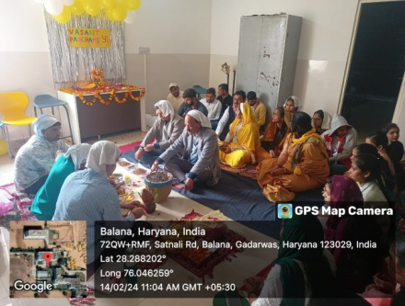
Photo 2 | 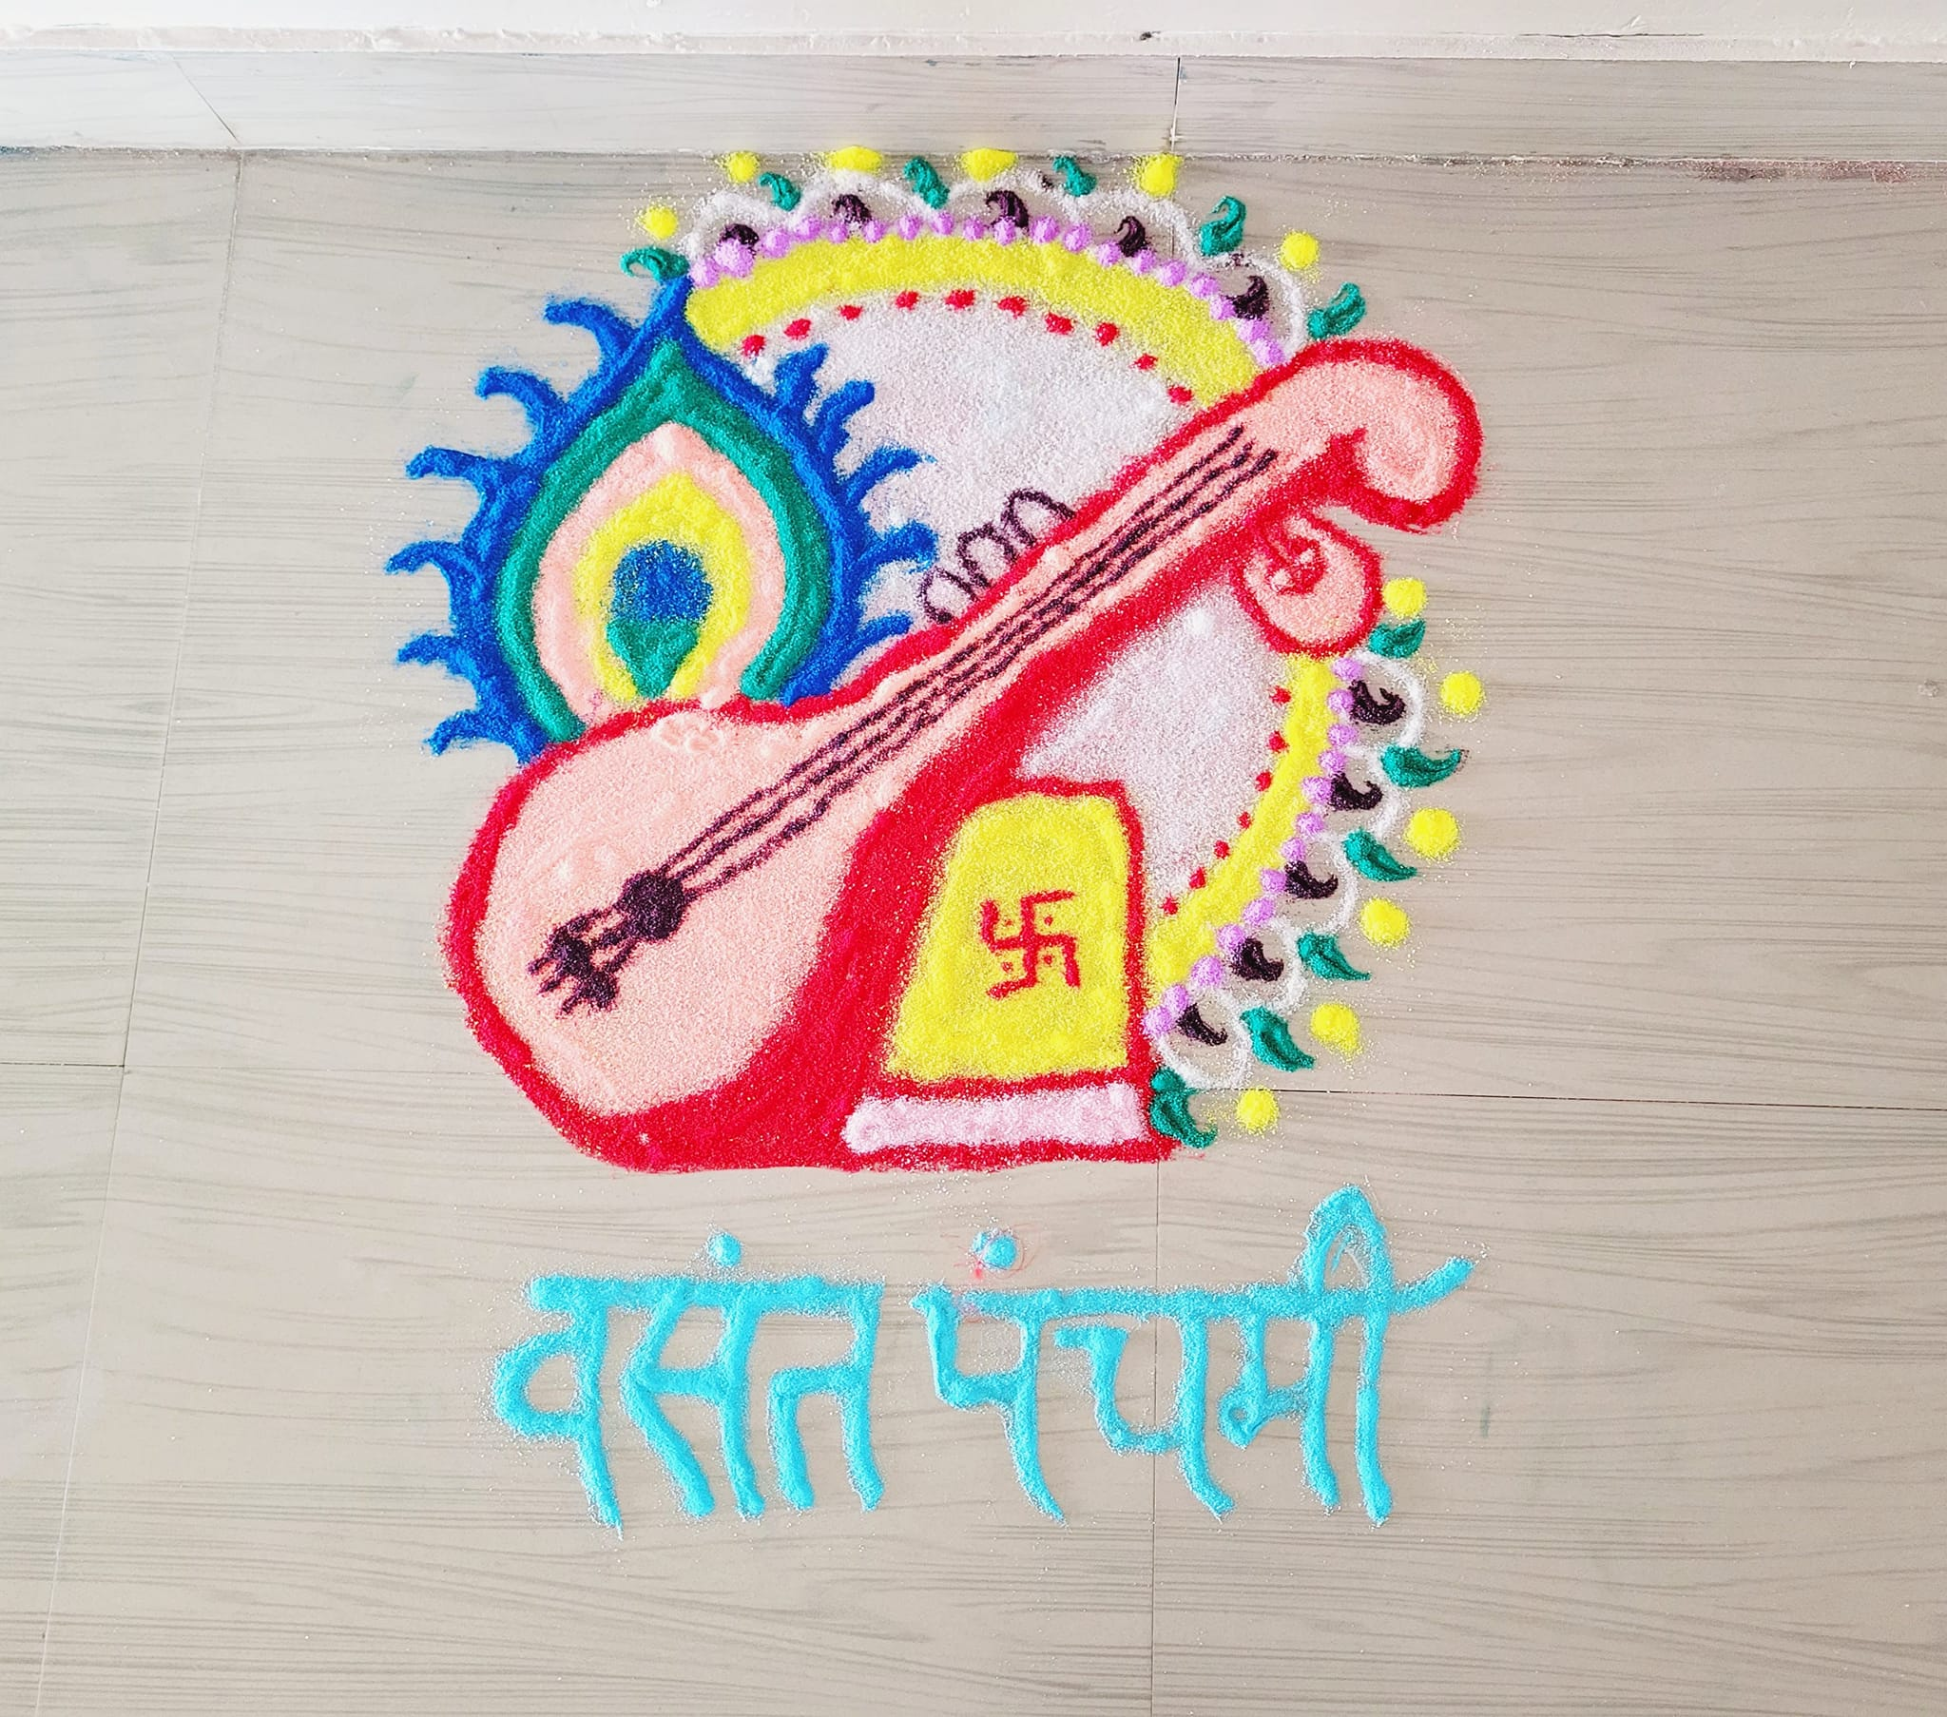

Photo 3 | 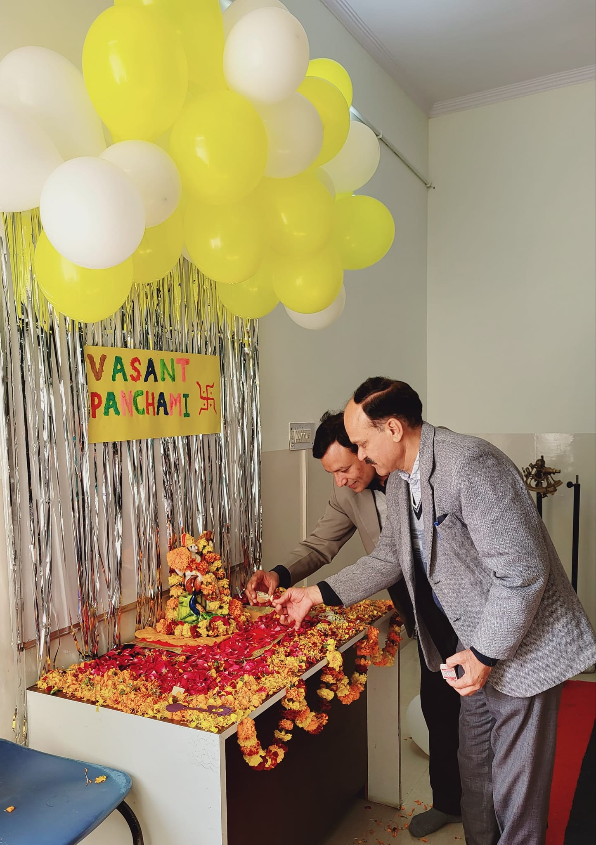

Photo 4 | 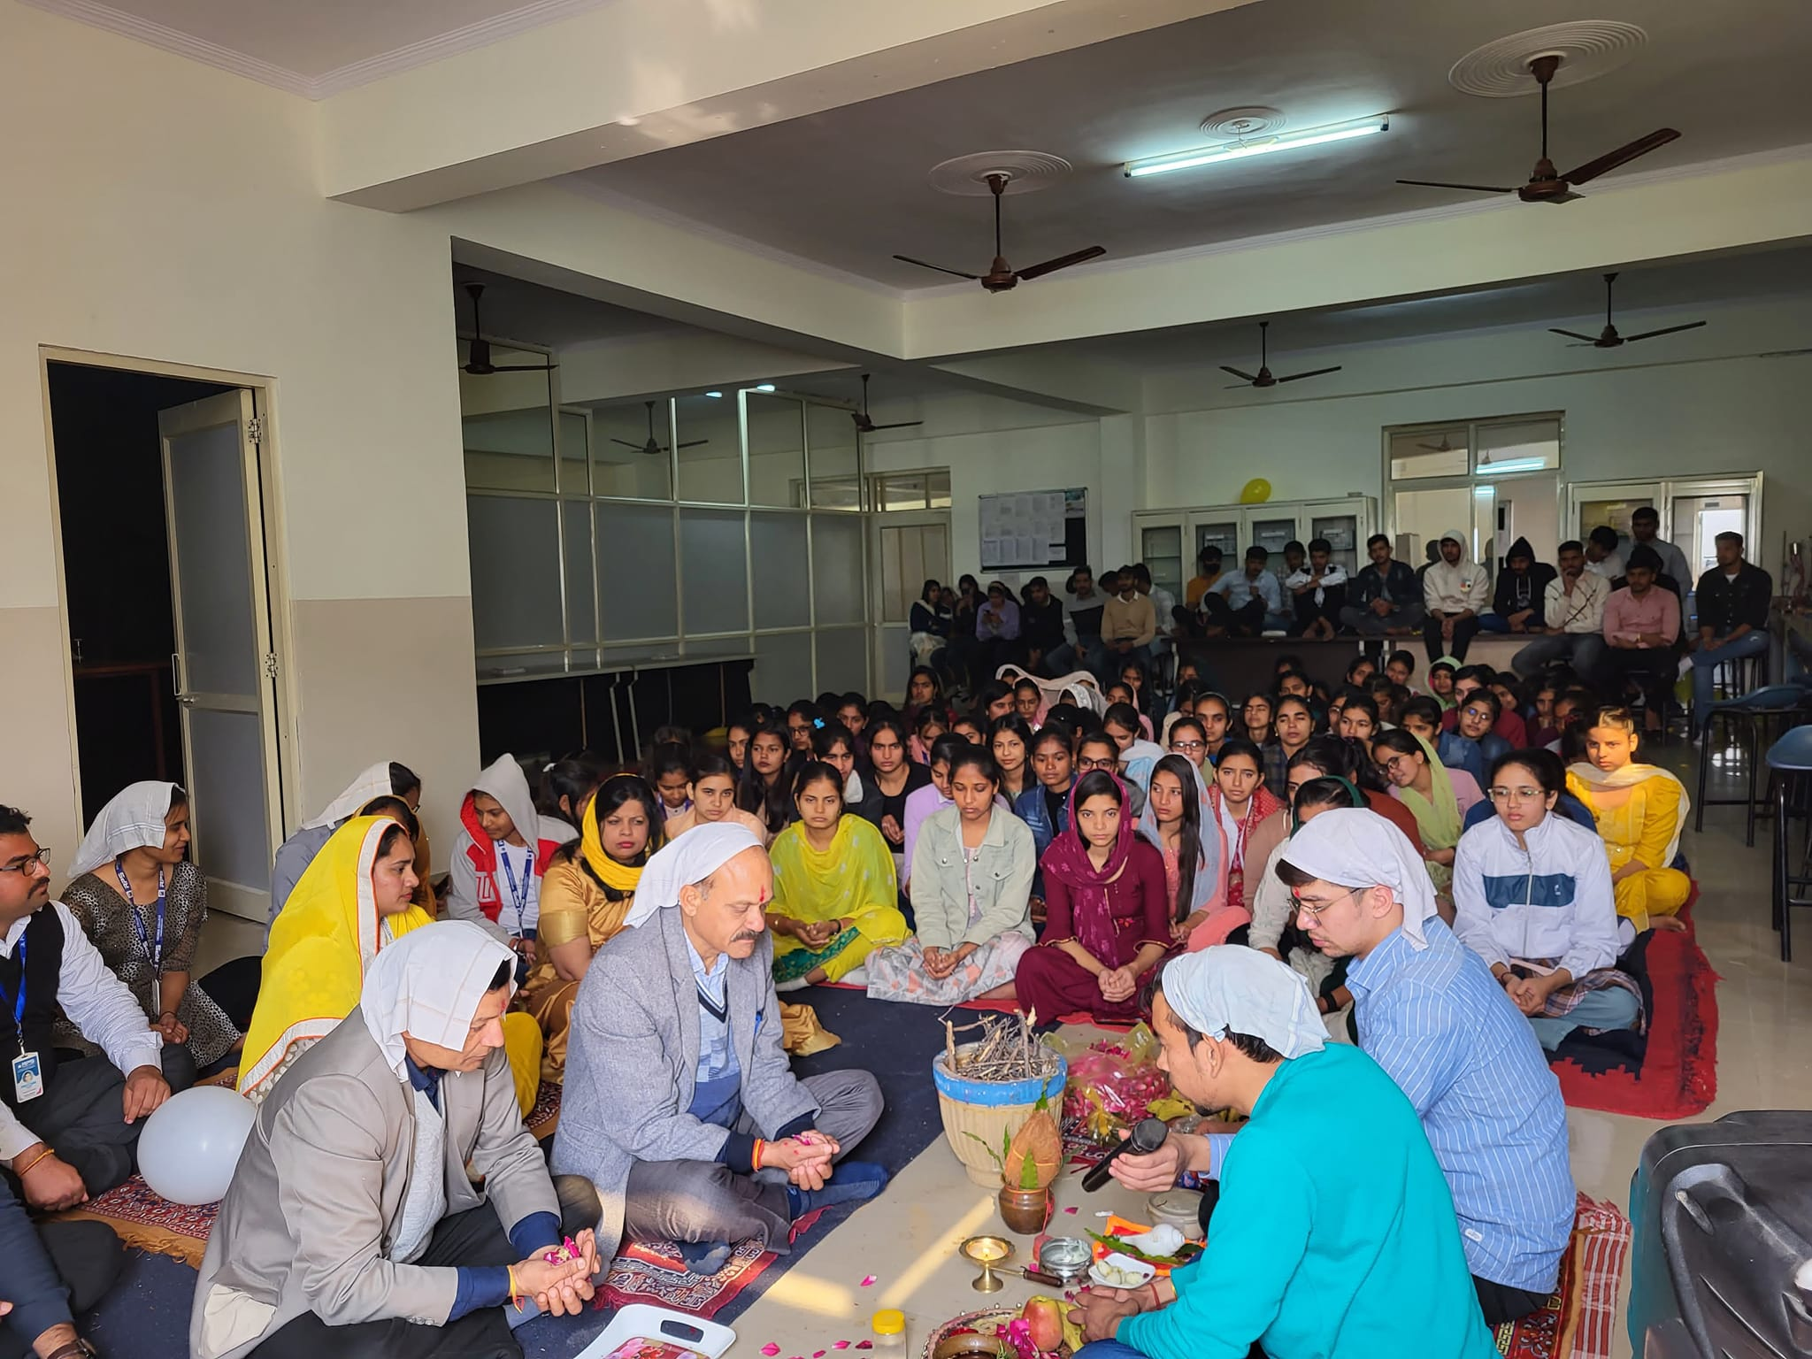

Photo 5

