Department | PHYSICS
Session | 2023-2024

Activity Name | National Conference at IGU, SEED - 2024
Short summary | Ms. Archana Sahoo and Mr. Sachin, assistant professor in the Department of Physics, along with 13 students of M.Sc. Physics 4th sem and 11 students of M.Sc. Physics 2nd sem, RPS Degree College, Balana, Mahendergarh attended a “National Conference at Indira Gandhi University, Meerpur, Rewari” dated 08-09 February 2024 on topic “Science for Equity Empowerment & Development”.  One of our M.Sc. students, Priyanka (22PHY12) was awarded with best poster presentation.  .

Photo 1 | 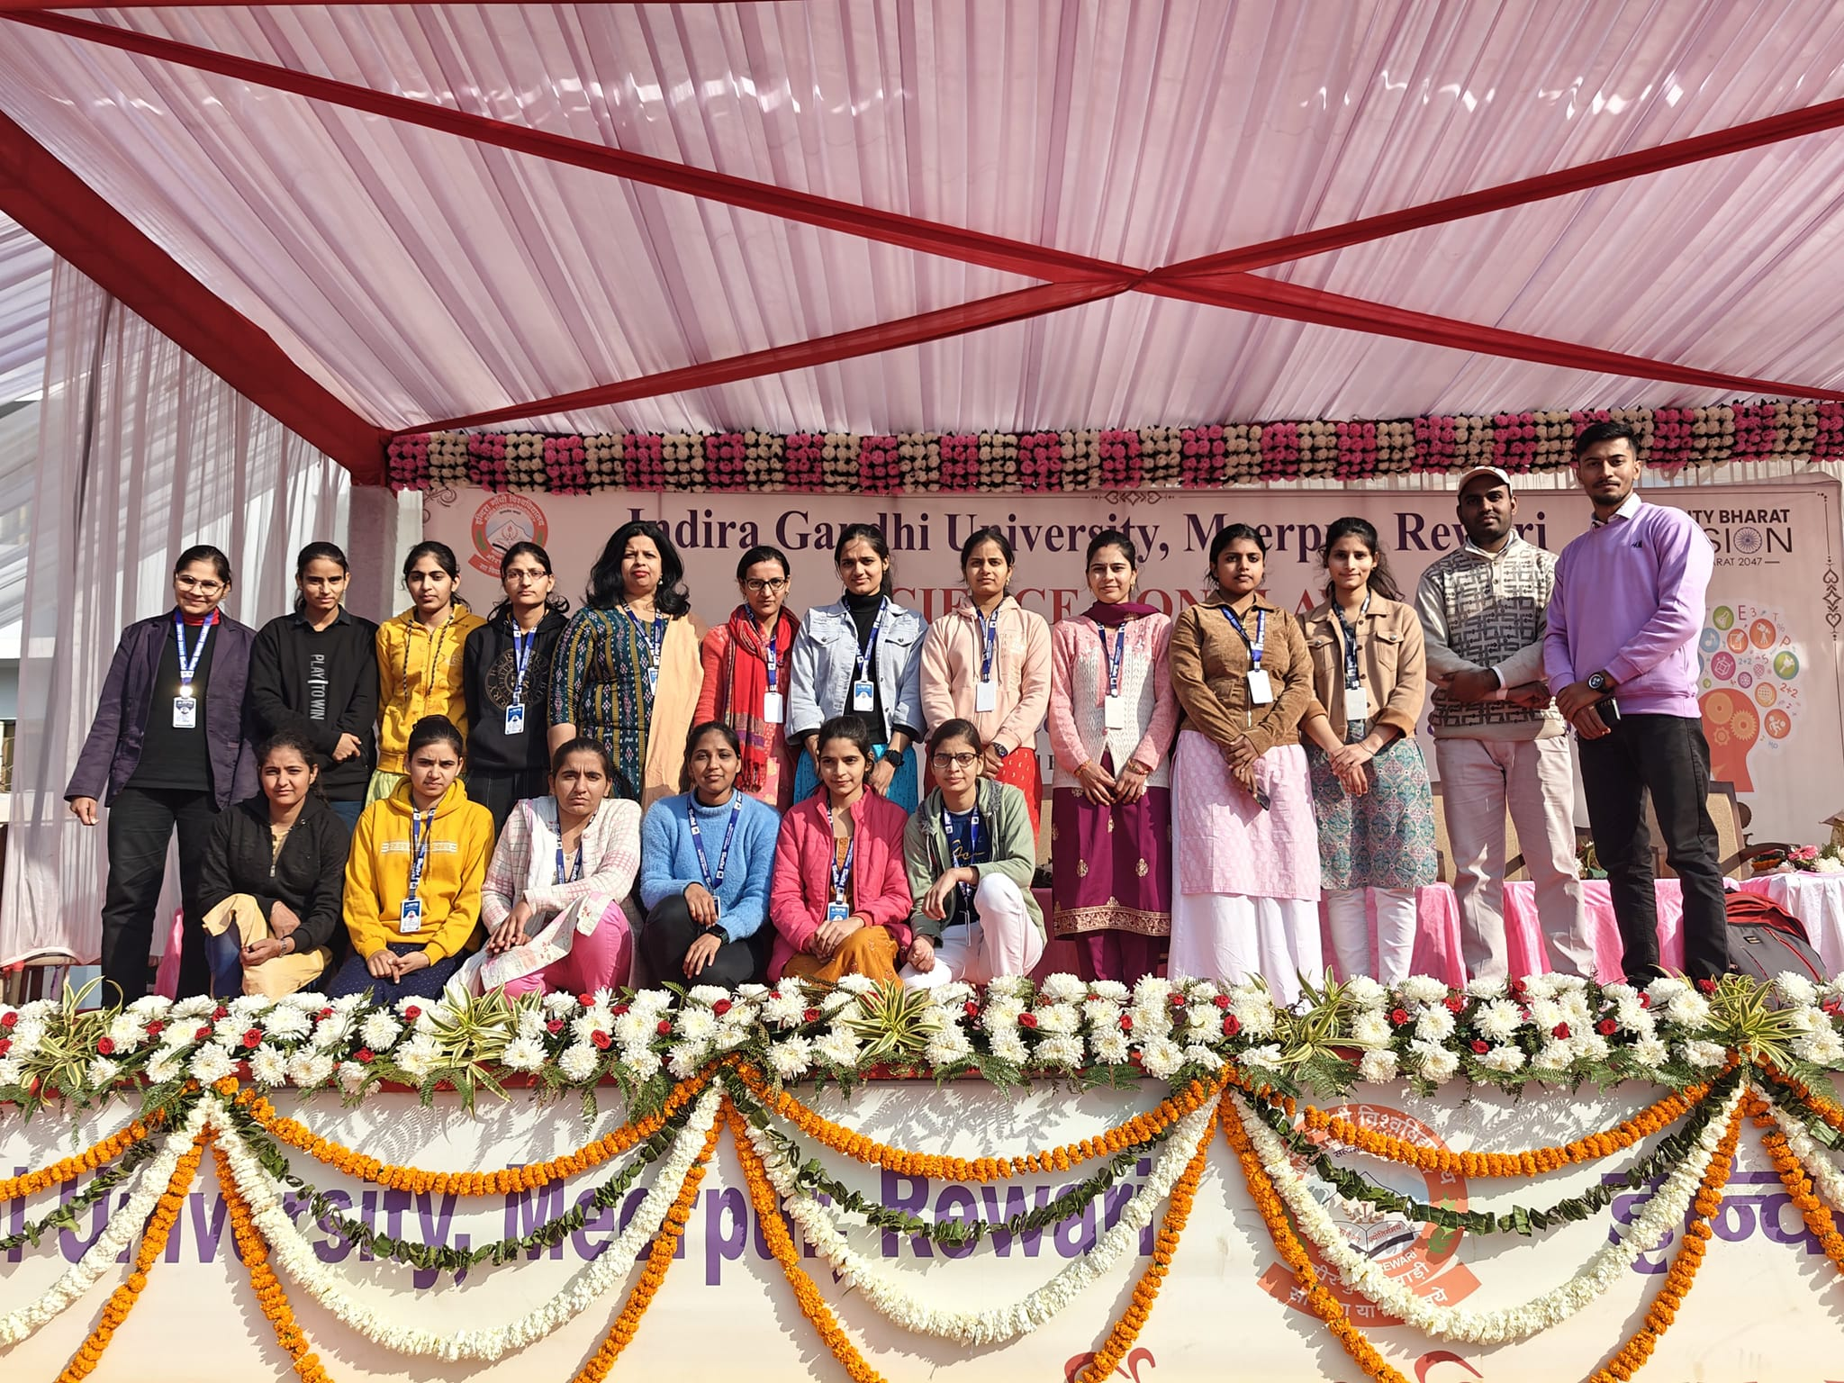
Photo 2 | 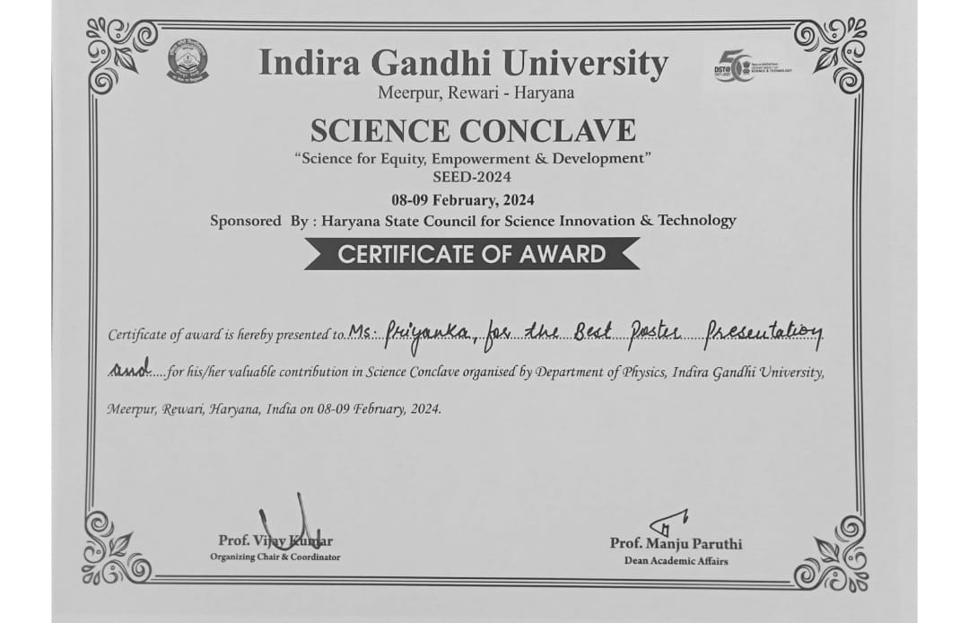

Photo 3 | 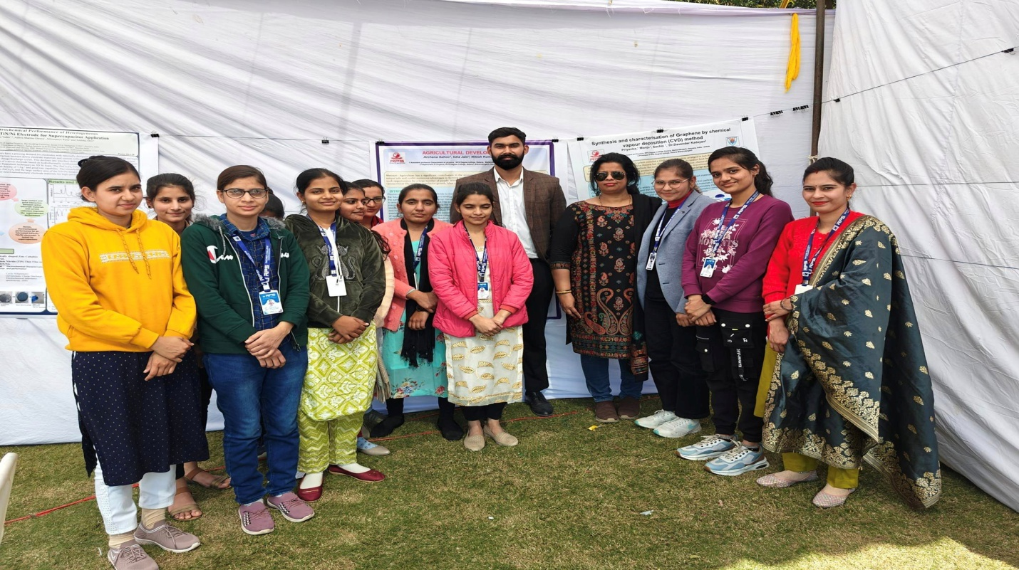

Photo 4 | 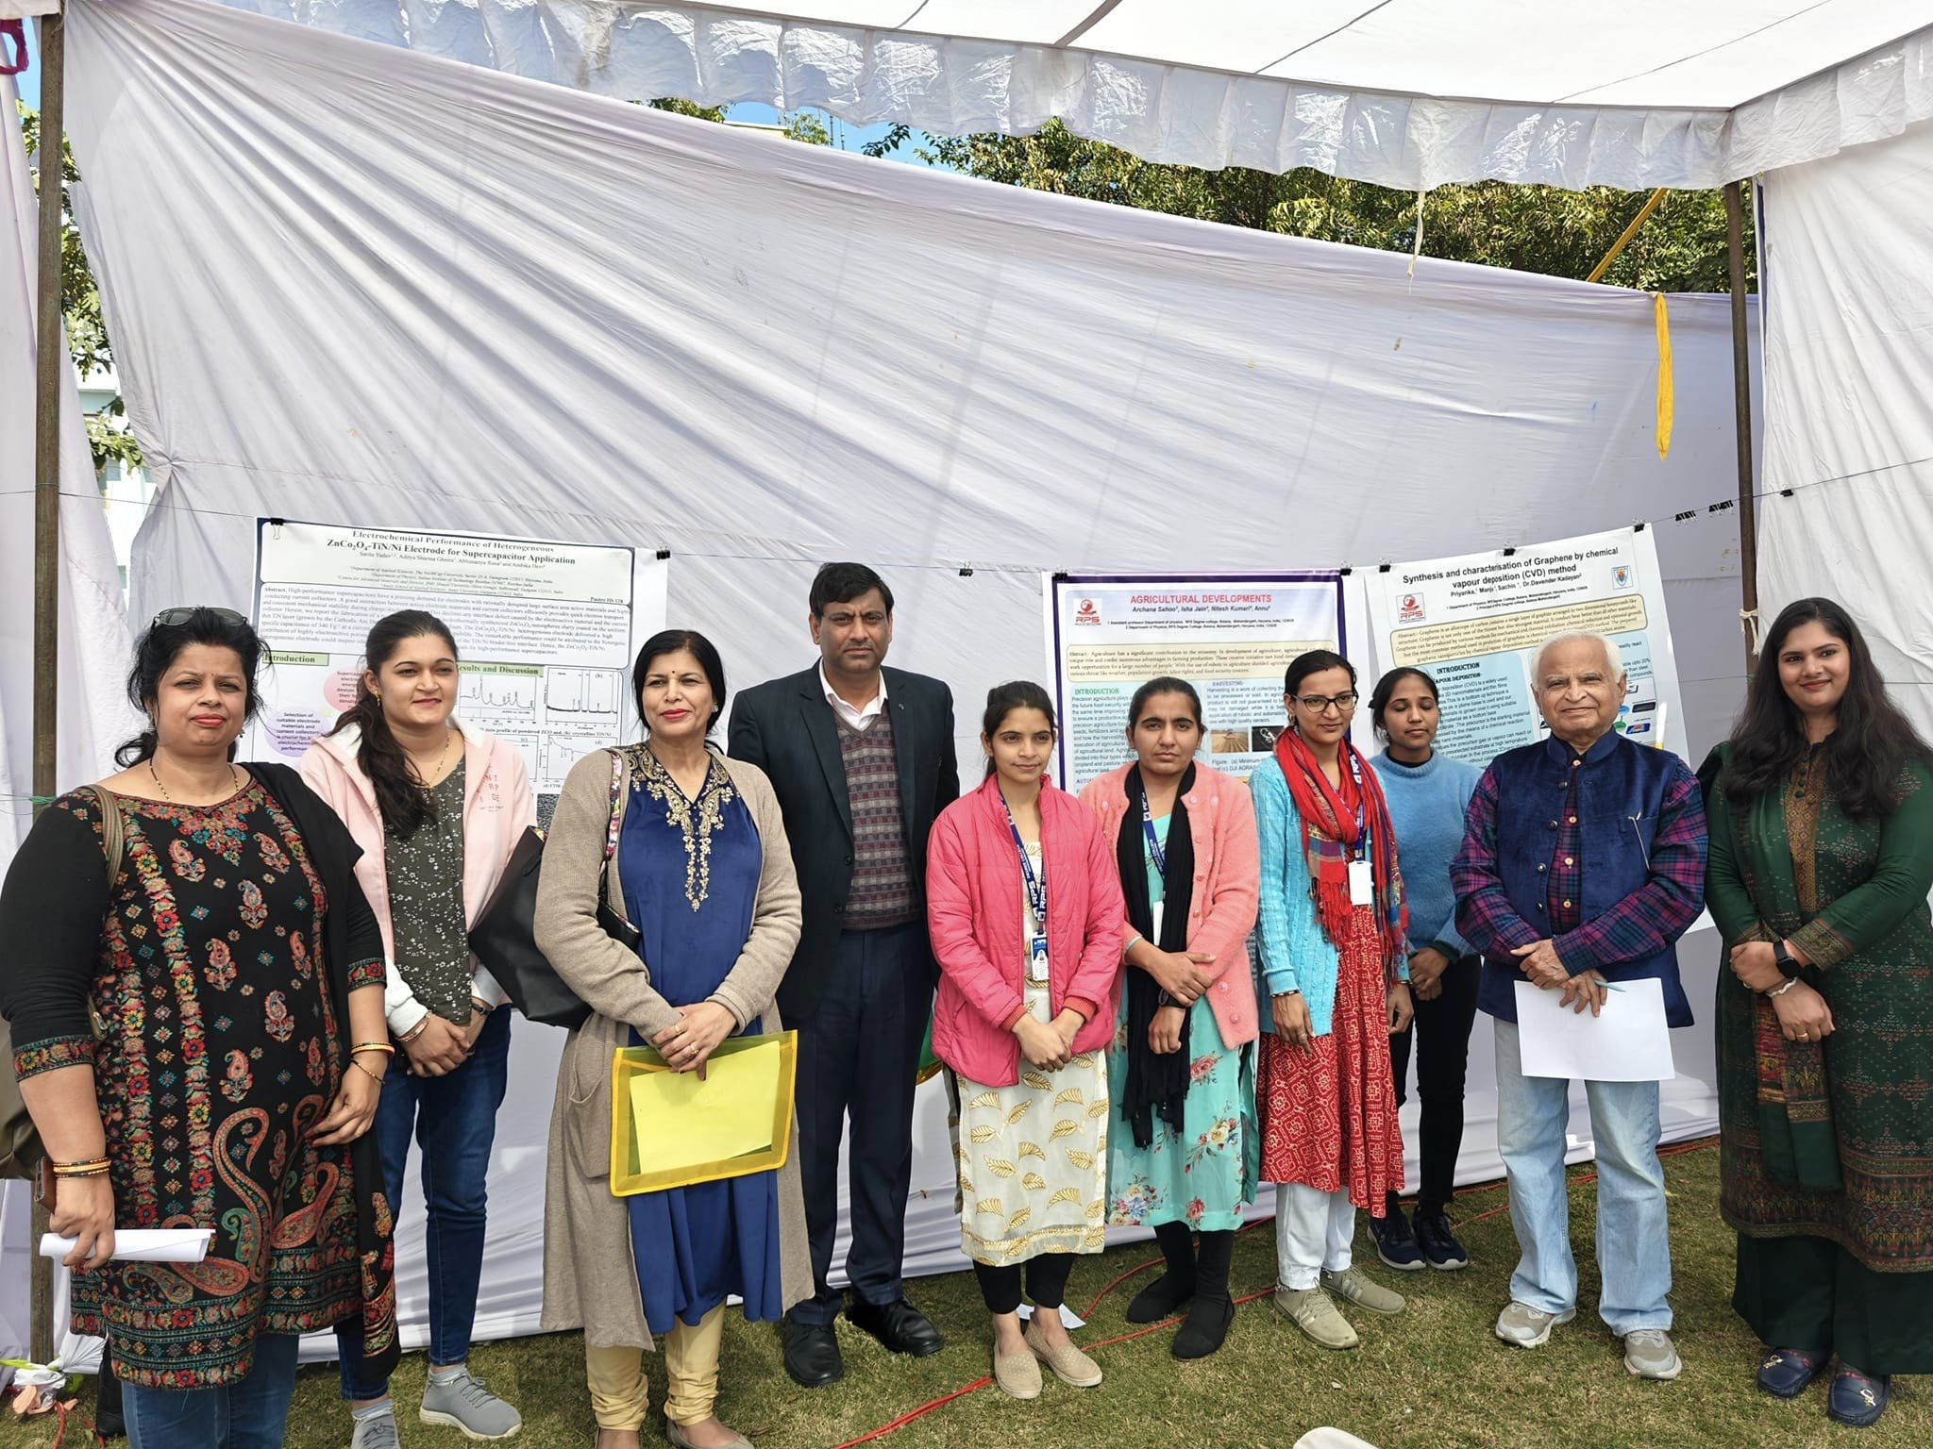

Photo 5 | 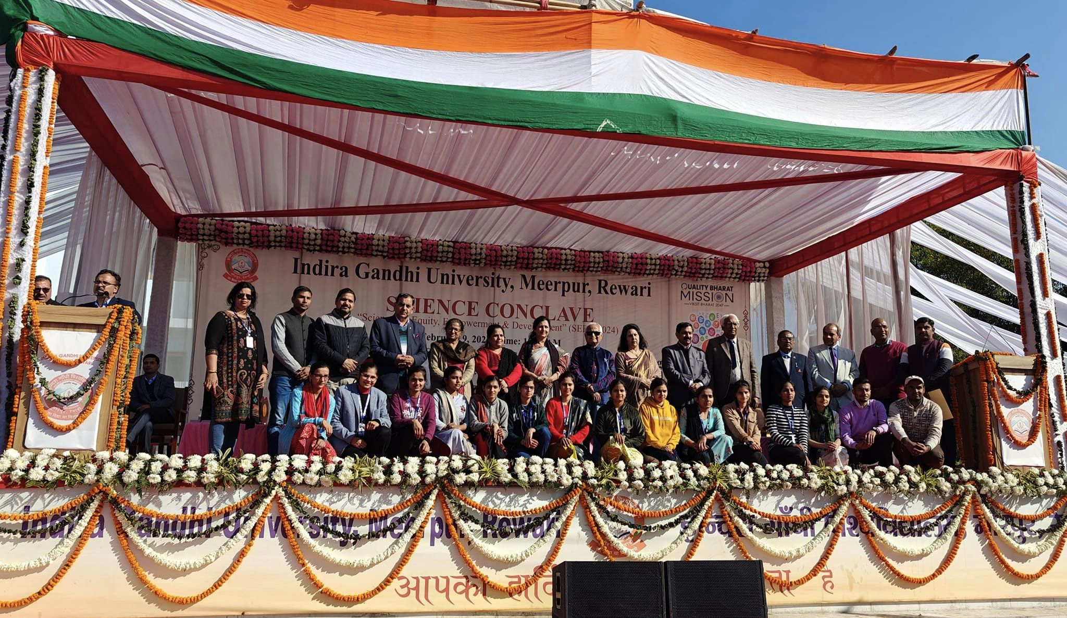

Photo 6 | 