Department | PHYSICS
Session | 2023-2024

Activity Name | Workshop CUH
Short summary | Students of Hons & M.Sc. Physics of RPS Degree College, Balana, Mahendergarh had participated in the workshop "Formation & Evolution of Galaxies" organized by Department of Physics & Astrophysics central University, Haryana from 18-20 March 2024.  .

Photo 1 | 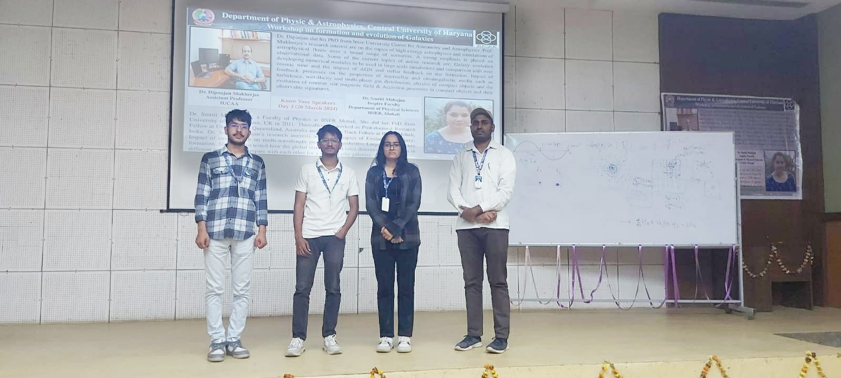
Photo 2 | 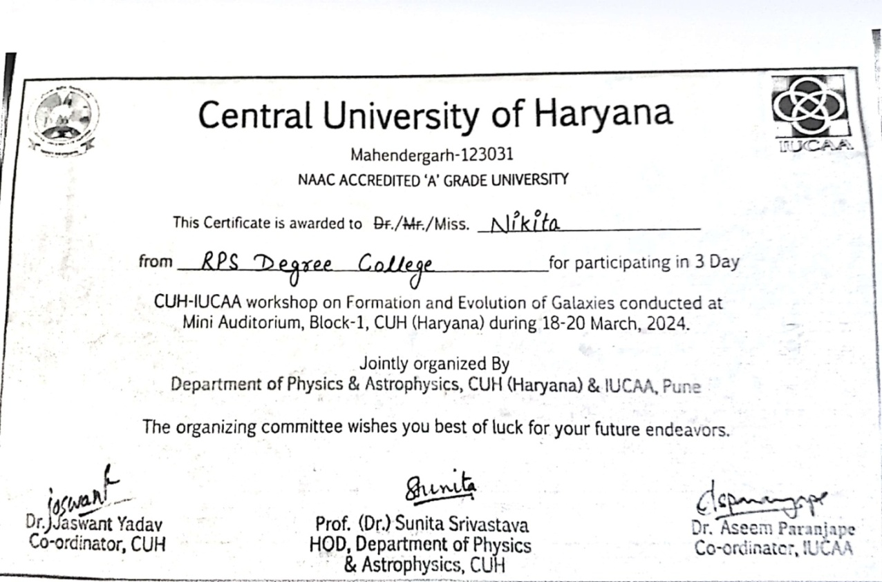

Photo 3 | 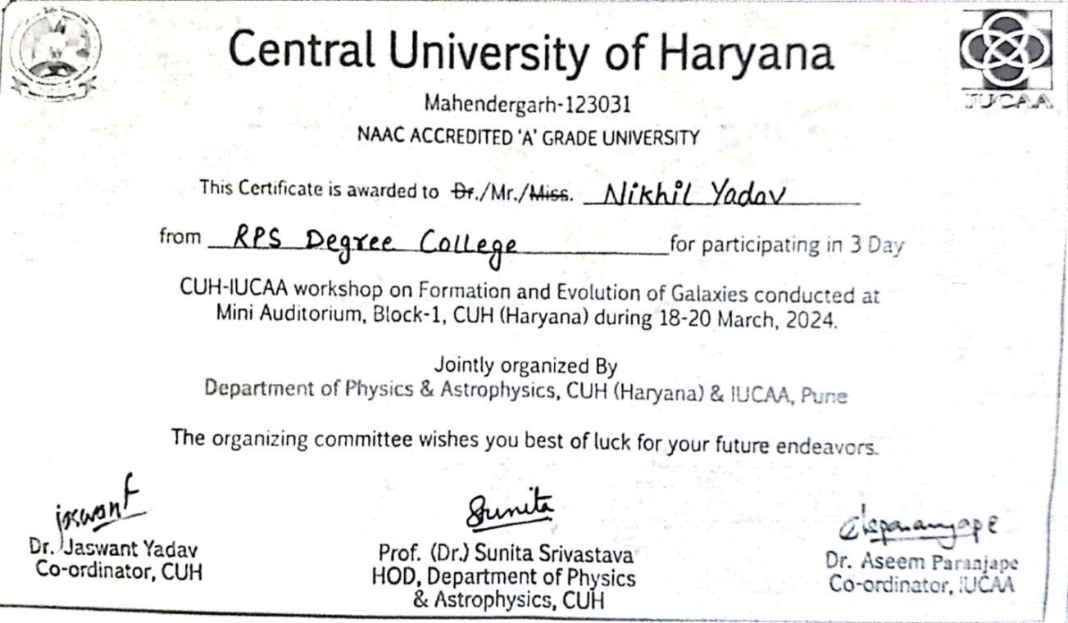

Photo 4 | 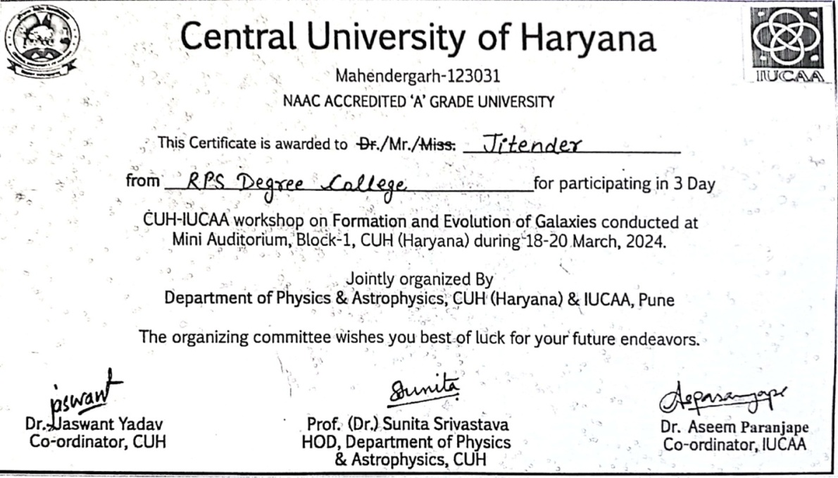  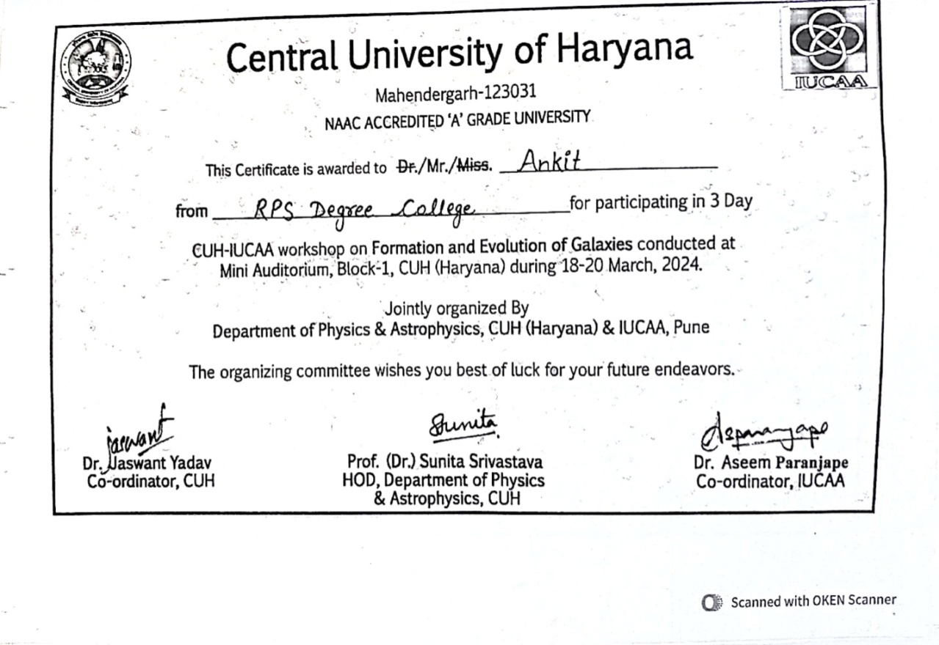

Photo 5 | 