Department | PHYSICS
Session | 2023-2024

Activity Name | Educational visit to ION BEAM CENTRE KUK - 2024
Short summary | The “BOSE SOCIETY”, Department of Physics, Rao Pahlad Singh Degree College, Balana, Mahendergarh, Haryana, has organized one day educational trip to visit Ion Beam Centre of Kurukshetra University, Kurukshetra on 03 rd April 2024.  It is anticipated that 07 students of Honors Physics 2nd sem, 10 students of Honors Physics 4th sem, 15 students of Honors Physics 6th sem and 13 students of M.Sc. (Physics) 4th sem, along with Dr. Kavita, Ms. Poonam, Mr. Praveen Kumar and Mr. Manjeet Kumar, Assistant Professor in the Department of Physics visited the institute. The programme offered an introductory lecture giving an overview of the facilities and the current research activities at Ion Beam Centre of Kurukshetra University, Kurukshetra. The students also visited the DHAROVAR at Kurukshetra University which is a museum to showcase the unique archeological, cultural and architectural heritage of Haryana. Visiting Ion Beam Centre, KUK, was a once in a lifetime opportunity for both faculties as well as students, an opportunity that could not be missed.  .

Photo 1 | 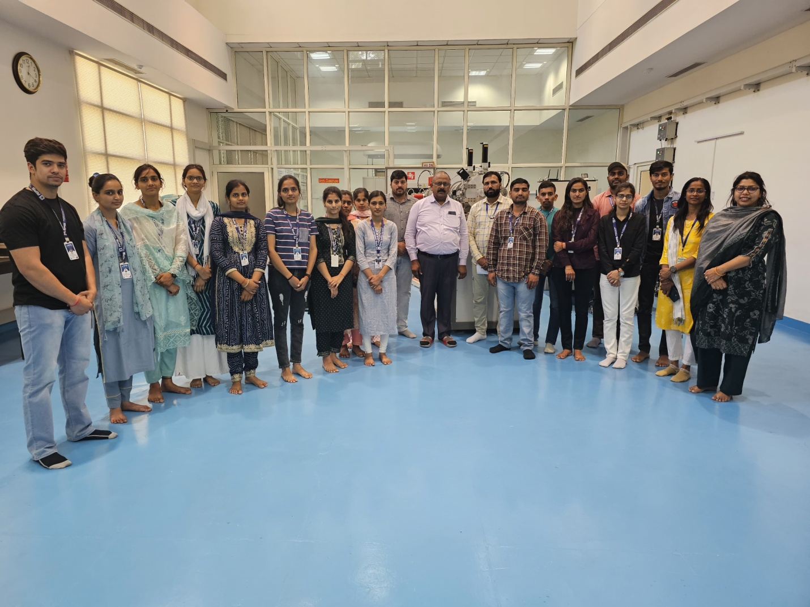
Photo 2 | 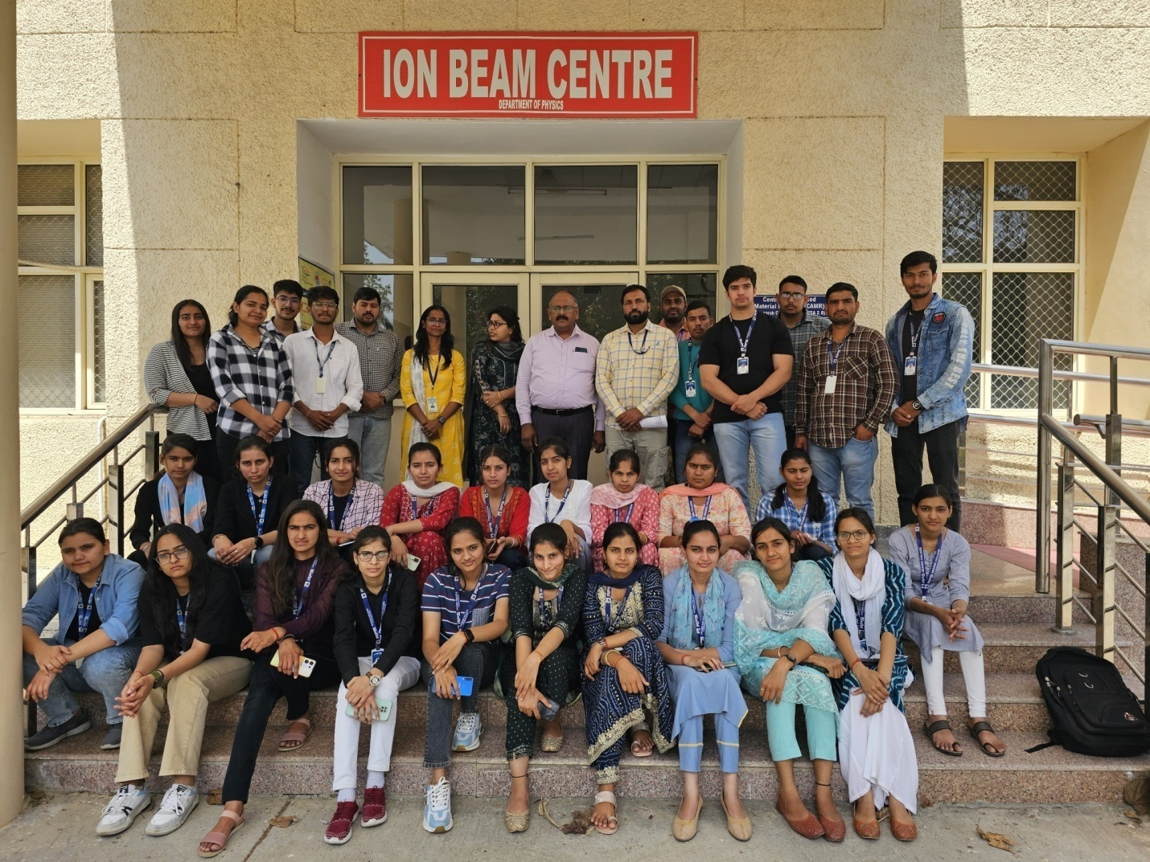

Photo 3 | 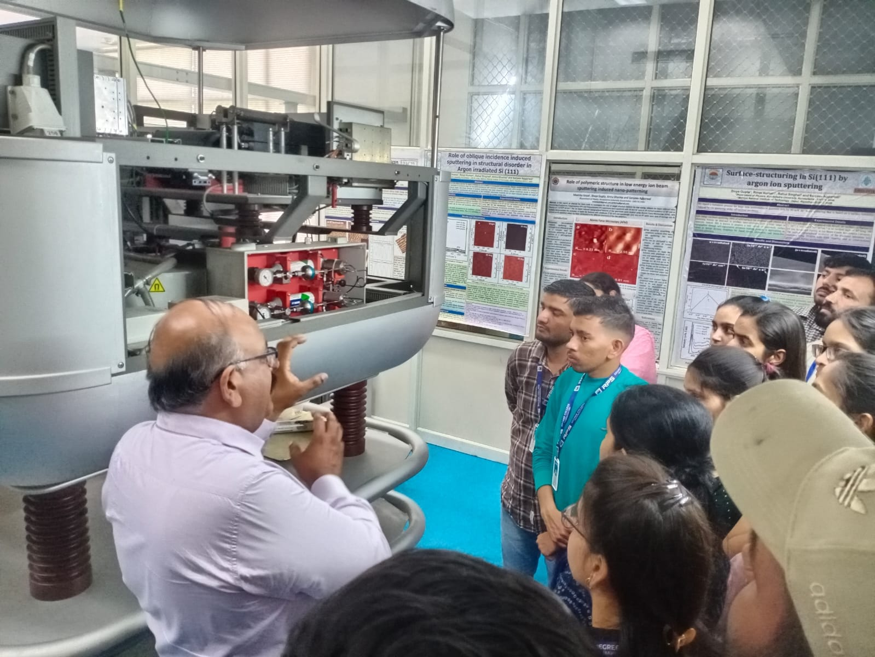

Photo 4 | 