Name | Dr. DAVENDER SINGH |  |  |  |  |  | 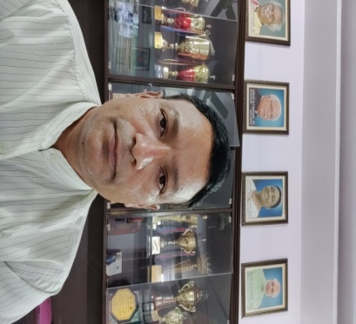
Designation | PRINCIPAL & PROFESSOR
Department | PHYSICS
Qualification | PhD. M.Phil, M.B.A. (Edu. Mgmt)&B.Ed.
Research & Teaching  Experience (in years) | Total |  |  | Teaching |  |  | Research
 | 23 |  |  | 23 |  |  | 14
Contact Details: | E-mail  dsk76mdu@gmail.com |  |  |  |  | Mobile/Phone  +919416248604
Books/Chapters Published | 05
Research Publications | International Journals |  | National Journals |  | International Conferences |  |  | National Conferences
 | 44 |  | 15 |  | 10 |  |  | 22
Research Guidance |  | Ph.D. |  | -- | Masters |  |  | ----
Research Projects |  | Completed |  | -- | In progress |  |  | -----
Consultancy Projects |  | Completed |  | 12 | In progress |  |  | 02
Seminar/Conference/STTPs |  | Attended |  | 20 | Organized |  |  | 08
Professional Affiliations
Awards/ Fellowships etc. |  | 05

