Name | Dr. Jyoti Yadav |  |  |  |  |  | 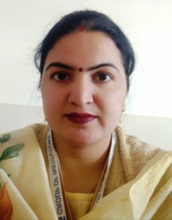
Designation | Assistant Professor
Department | Physics
Qualification | M. Sc. (Physics), NET-JRF, GATE, Ph. D.
Research | Piezoelectric Energy Harvesting
Experience (in years) | Total  8 |  |  | Teaching  3.5 |  |  | Research  4.5
Contact Details: | decentjyoti7@gmail.com |  |  |  |  | 7876138533
Books/Chapters Published | -
Research Publications | International Journals |  | National Journals |  | International Conferences |  |  | National Conferences
 | 10 |  | - |  | - |  |  | -
Research Guidance |  | Ph.D. |  | - | Masters |  |  | -
Research Projects |  | Completed |  | - | Inprogress |  |  | -
Consultancy Projects |  | Completed |  | - | Inprogress |  |  | -
Seminar/Conference/STTPs |  | Attended |  | 23 | Organized |  |  | -
Professional Affiliations |  | Rao Pahlad Singh Degree College, IGU, Meerpur, Rewari
Awards/ Fellowships etc. |  | NET- JRF, SRF

