Name | SACHIN |  |  |  |  |  | 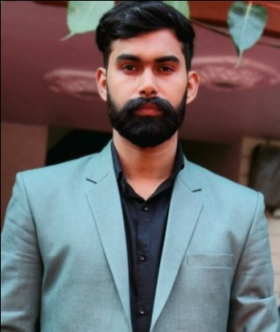
Designation | Assistant Professor
Department | PHYSICS
Qualification | M.Sc. PHYSICS , Ph.D*  CSIR NET-JRF, GATE, CTET
Research | METAL OXIDE NANOPARTICLES
Experience (in years) | Total  06 Years |  |  | Teaching  06 Years |  |  | Research  03 Years
Contact Details: | E-mail  Sachinsura04@gmail.com |  |  |  |  | Mobile/Phone  8901080222
Books/Chapters Published
Research Publications | International Journals |  | National Journals |  | International Conferences |  |  | National Conferences
 | 0 |  | 0 |  | 2 |  |  | 5
Research Guidance |  | Ph.D. |  |  | Masters
Research Projects/PATENT |  | Completed |  | 1 | Inprogress
Consultancy Projects |  | Completed |  |  | Inprogress
Seminar/Conference/STTPs |  | Attended |  | 10 | Organized
Professional Affiliations |  | IGU Meerpur, Rewari
Awards/ Fellowships etc. |  | CSIR NET, GATE

