Name | Dr. Jitendra Kumar |  |  |  |  |  | 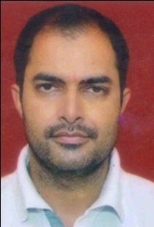
Designation | Controller of Examination
Department | Physics
Qualification | M.Sc.(Physics), M.Phil(Instrumentation), Ph.D.
Research | Toxic Gas Sensor & Conducting polymaers
Experience (in years) | Total  10.5 |  |  | Teaching  6.5 |  |  | Research  4
Contact Details: | E-mail  Jk.jaat@gmail.com |  |  |  |  | Mobile/Phone  8168149622
Books/Chapters Published | International Conference on Material Science, Technology & Sustainable Environment (ISBN NO. 978-81-19813-21-6)
Research Publications | International Journals |  | National Journals |  | International Conferences |  |  | National Conferences
 | 07 |  | - |  | 01 |  |  | -
Research Guidance |  | Ph.D. |  | 03 | Masters |  |  | 80
Research Projects |  | Completed |  | - | Inprogress |  |  | -
Consultancy Projects |  | Completed |  | - | Inprogress |  |  | -
Seminar/Conference/STTPs |  | Attended |  | 15 | Organized |  |  | 01
Professional Affiliations |  | Rao Pahlad Singh Degree College, IGU, Meerpur, Rewari, Haryana, Bharat
Awards/ Fellowships etc. |  | - Research Intern (Diamond jubilee fellowship) CSIR-NPL, Govt. of India.  - NASA project fellowship University of Puerto Rico, USA.

