Name | Dr. Rahul Sharma |  |  |  |  |  | 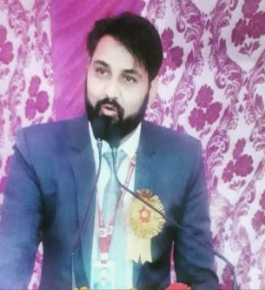
Designation | Assistant Professor
Department | Geography
Qualification | M.Sc. , NET, HTET, B.Ed.
Research | Yes
Experience (in years) | Total  4 years |  |  | Teaching  4 |  |  | Research  7
Contact Details: | E-mail  Sharma.rahul32299@gmail.com |  |  |  |  | Mobile/Phone  9467932321
Books/Chapters Published | 1 Book
Research Publications | International Journals |  | National Journals |  | International Conferences |  |  | National Conferences
 | 2 |  | 2 |  | 4 |  |  | 4
Research Guidance |  | Ph.D. |  |  | Masters
Research Projects |  | Completed |  |  | Completed
Consultancy Projects |  | Completed |  |  | Completed
Seminar/Conference/STTPs |  | Attended |  |  | Organized
Professional Affiliations
Awards/ Fellowships etc.

