Name | Dr Rajesh kumar |  |  |  |  |  | 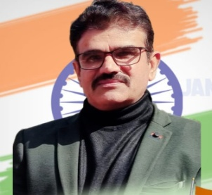
Designation | Head
Department | Humanities
Qualification | M.A,B.Ed,Ph.D
Research
Experience (in years) | Total  14 |  |  | Teaching |  |  | Research
Contact Details: | raazdagar@gmail.com |  |  |  |  | Mobile/9813179800
Books/Chapters Published | NA
Research Publications | International Journals |  | National Journals |  | International Conferences |  |  | National Conferences
 |  |  | 2
Research Guidance |  | Ph.D. |  |  | Masters
Research Projects |  | Completed |  |  | Inprogress
Consultancy Projects |  | Completed |  |  | Inprogress
Seminar/Conference/STTPs |  | Attended |  | 5 | Organized
Professional Affiliations
Awards/ Fellowships etc.

