Name | Dr. Sangeeta kumari |  |  |  |  |  |  | 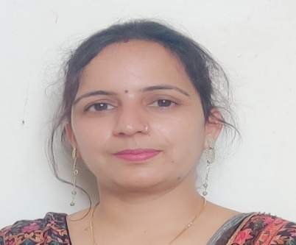
Designation | Assistant professor
Department | Life sciences, botany
Qualification | M.Sc. (Botany), UGC-CSIR –NET, PhD.
Research
Experience (in years) | Total  9years |  |  | Teaching  4years |  |  | Research  5 years
Contact Details: | E-mail  sangeetaghalawat@gmail.com |  |  |  |  | Mobile/Phone  7027770424 / 9255418360
Books/Chapters Published
Research Publications | International Journals |  | National Journals |  | International Conferences |  |  |  | National Conferences
 | 2 |  | 6 |  | 3 |  |  |  | 4
Research Guidance |  | Ph.D. |  | Thesis submitted | Masters |  |  |  | Done
Research Projects |  |  |  |  |  |  |  |  | NIL
Consultancy Projects |  |  |  |  |  |  |  |  | NIL
Seminar/Conference/STTPs |  | Attended
Professional Affiliations
Awards/ Fellowships etc. |  | University Research Scholarship
2

