Name | Ombir Singh Tanwar |  |  |  |  |  | 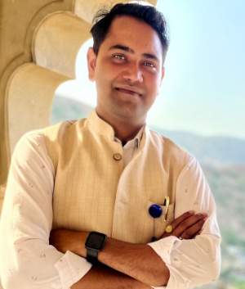
Designation | Assistant professor
Department | Division of Special Classes
Qualification | M.Sc.
Research | 00
Experience (in years) | Total  12 years |  |  | Teaching  12 years |  |  | Research
Contact Details: | E-mail  ostanwar@gmail.com |  |  |  |  | Mobile/Phone  8295107244
Books/Chapters Published | 00
Research Publications | International Journals |  | National Journals |  | International Conferences |  |  | National Conferences
 | 00
Research Guidance |  | Ph.D. |  |  | Masters
Research Projects |  | Completed |  |  | Inprogress
Consultancy Projects |  | Completed |  |  | Inprogress
Seminar/Conference/STTPs |  | Attended |  | 00 | Organized
Professional Affiliations
Awards/ Fellowships etc.

