Name | Rakesh Kumar |  |  |  |  |  | 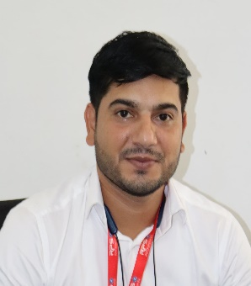
Designation | Clerk
Department | Accounts
Qualification | B.Tech
Research
Experience (in years) | Total  07 Years |  |  | Teaching |  |  | Research
Contact Details: | E-mail  rakesh11ec48@gmail.com |  |  |  |  | Mobile/Phone  8222822464
Books/Chapters Published
Research Publications | International Journals |  | National Journals |  | International Conferences |  |  | National Conferences
Research Guidance |  | Ph.D. |  |  | Masters
Research Projects |  | Completed |  |  | Inprogress
Consultancy Projects |  | Completed |  |  | Inprogress
Seminar/Conference/STTPs |  | Attended |  |  | Organized
Professional Affiliations
Awards/ Fellowships etc.

