Name | Birakh Bhan |  |  |  |  |  | 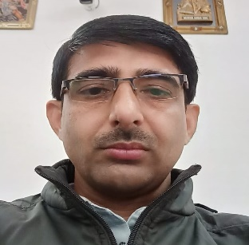
Designation | Account Clerk
Department | Account Branch
Qualification | M.A B.ED
Research
Experience (in years) | Total  11 Years |  |  | Teaching |  |  | Research
Contact Details: | E-mail |  |  |  |  | Mobile/Phone
Books/Chapters Published
Research Publications | International Journals |  | National Journals |  | International Conferences |  |  | National Conferences
Research Guidance |  | Ph.D. |  |  | Masters
Research Projects |  | Completed |  |  | Inprogress
Consultancy Projects |  | Completed |  |  | Inprogress
Seminar/Conference/STTPs |  | Attended |  |  | Organized
Professional Affiliations
Awards/ Fellowships etc.

