Name | Dr. D R Bharadwaj |  |  |  |  |  | 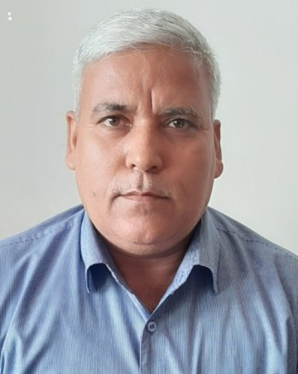
Designation | Head
Department | Botany
Qualification | MSc PhD
Research
Experience (in years) | Total  27 |  |  | Teaching  25 |  |  | Research  27
Contact Details: | E-mail  bioheadrps@gmail.com |  |  |  |  | Mobile/Phone  9416753021
Books/Chapters Published | 4
Research Publications | International Journals |  | National Journals |  | International Conferences |  |  | National Conferences
 | 4 |  | 4 |  | 8 |  |  | 10
Research Guidance |  | Ph.D. |  | 1 | Masters |  |  | 120
Research Projects |  | Completed |  |  | Inprogress
Consultancy Projects |  | Completed |  |  | Inprogress
Seminar/Conference/STTPs |  | Attended |  | 25 | Organized |  |  | 4
Professional Affiliations
Awards/ Fellowships etc. |  | Post Doctoral Fellowship of  Swedish Agriculture University

