Name | Dr.Dushyant |  |  |  |  |  | 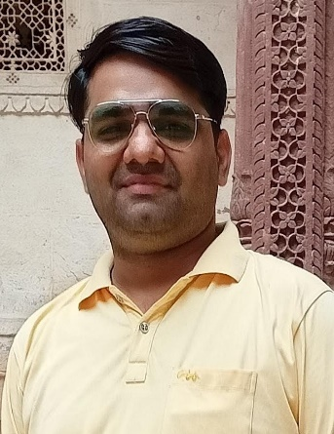
Designation | Assistant Professor
Department | Mathematics
Qualification | M.Sc,NET,Ph.D
Research
Experience (in years) | Total  14 |  |  | Teaching  14 |  |  | Research
Contact Details: | E-mail  dushyantkaushik4765@gmail.com |  |  |  |  | Mobile/Phone  8950482896
Books/Chapters Published
Research Publications | International Journals |  | National Journals |  | International Conferences |  |  | National Conferences
 | 3
Research Guidance |  | Ph.D. |  |  | Masters
Research Projects |  | Completed |  |  | Inprogress
Consultancy Projects |  | Completed |  |  | Inprogress
Seminar/Conference/STTPs |  | Attended |  | Yes | Organized
Professional Affiliations |  | Approved faculty from IGU Meerpur
Awards/ Fellowships etc.

