Name | Ajay |  |  |  |  |  | 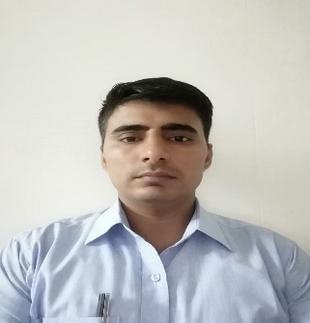
Designation | Asst. Prof.
Department | Mathematics
Qualification | M.Sc., B.Ed.
Research
Experience (in years) | Total  08 years 2 months |  |  | Teaching  08 years |  |  | Research
Contact Details: | E-mail  Ajaybaland2008@gmail.com |  |  |  |  | Mobile/Phone  9017398945
Books/Chapters Published
Research Publications | International Journals |  | National Journals |  | International Conferences |  |  | National Conferences
Research Guidance |  | Ph.D. |  |  | Masters
Research Projects |  | Completed |  |  | Inprogress
Consultancy Projects |  | Completed |  |  | Inprogress
Seminar/Conference/STTPs |  | Attended |  |  | Organized
Professional Affiliations
Awards/ Fellowships etc.

