Name | Dr. Anuradha |  |  |  |  |  | 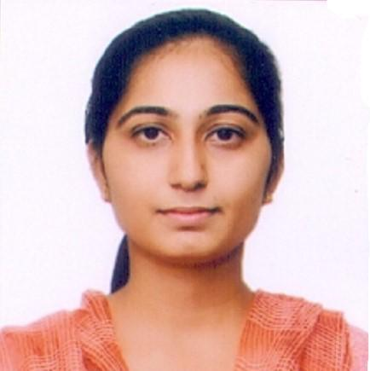
Designation | Assistant Professor
Department | Department of chemistry
Qualification | M.Sc., Ph.D.
Research | Hybrid composite materials for environmental remediation- Thermodynamic, Adsorption and Photocatalytic aspects
Experience (in years) | Total  Five years |  |  | Teaching  Six months |  |  | Research  Four and half years
Contact Details: | E-mail  arsharma.chem@gmail.com |  |  |  |  | Mobile/Phone  9034472029
Books/Chapters Published | One
Research Publications | International Journals |  | National Journals |  | International Conferences |  |  | National Conferences
 | 24 |  |  |  | 4 |  |  | 2
Research Guidance |  | Ph.D. |  | NIL | Masters |  |  | NIL
Research Projects |  | Completed |  | NIL | Inprogress |  |  | NIL
Consultancy Projects |  | Completed |  | NIL | Inprogress |  |  | NIL
Seminar/Conference/STTPs |  | Attended |  | NIL | Organized |  |  | NIL
Professional Affiliations |  | Maharshi Dayanand University, Rohtak
Awards/ Fellowships etc. |  | CSIR –JRF (DEC 2017)

