Name | Dr. Anil Kumar |  |  |  |  | 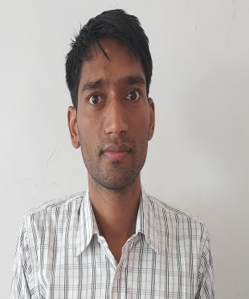
Designation | Assistant Professor
Department | Chemistry
Qualification | Ph.D.
Research | Development of new synthetic methods via N-Heterocyclic Carbene Catalysis
Experience(inyears) | Total  1 year |  |  | Teaching  1 year |  | Research
ContactDetails: | E-mail gujjaranilkhatana@gmail.com |  |  |  | Mobile/Phone  8787055735
Books/ChaptersPublished
ResearchPublications | InternationalJournals |  | National  Journals |  | International  Conferences |  | National  Conferences
 | 8 |  | 0 |  | 1 |  | 2
ResearchGuidance |  | Ph.D. |  | NIL | Masters |  | NIL
ResearchProjects |  | Completed |  | NIL | In progress |  | NIL
ConsultancyProjects |  | Completed |  | NIL | In progress |  | NIL
Seminar/Conference/STTPs |  | Attended |  | NIL | Organized |  | NIL
ProfessionalAffiliations |  | Central University of Haryana and Centre of Biomedical Reasearch Lucknow.
Awards/Fellowshipsetc. |  | CSIR JRF Dec 2015, GATE 2016.

