Name | Vikash Kumar |  |  |  |  |  | 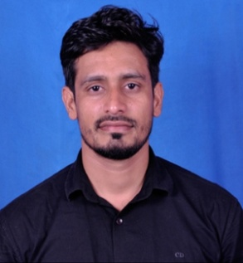
Designation | Asst. Professor
Department | Mathematics
Qualification | M.Sc, NET
Research
Experience (in years) | Total  7 |  |  | Teaching  7 |  |  | Research
Contact Details: | E-mail  Vikashnirban@gmail.com |  |  |  |  | Mobile/Phone  7056557211
Books/Chapters Published
Research Publications | International Journals |  | National Journals |  | International Conferences |  |  | National Conferences
Research Guidance |  |  |  |  | Masters
Research Projects |  | Completed
Consultancy Projects
Seminar/Conference/STTPs |  | Attended
Professional Affiliations
Awards/ Fellowships etc.

