Name | Dr. Deepak Rohilla |  |  |  |  | 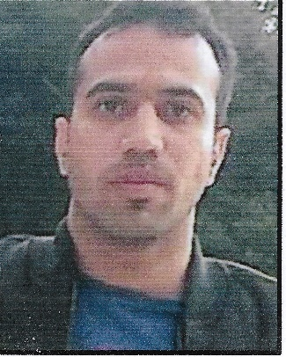
Designation | Assistant Professor
Department | Chemistry
Qualification | Ph.D.  Department of Chemistry  Panjab University Chandigarh
Research | Sensing and degradation of toxins using potential nanomaterials
Experience (in years) | Total  2 years |  |  | Teaching  1year |  | Research  1year
Contact Details: | E-mail: - chemdeepakrohilla  @gmail.com |  |  |  | Mobile/Phone  9877011923
Books/Chapters Published | NIL
Research Publications | International Journals |  | National  Journals |  | International  Conferences |  | National  Conferences
 | 7 |  | 0 |  | 10 |  | 12
Research Guidance |  | Ph.D. |  | NIL | Masters |  | NIL
Research Projects |  | Completed |  | NIL | In progress |  | NIL
Consultancy Projects |  | Completed |  | NIL | In progress |  | NIL
Seminar/Conference/STTPs |  | Attended |  | 15 | Organized |  | NIL
Professional Affiliations |  | Panjab University, Chandigarh
Awards/Fellowships etc. |  | CSIR-NET, President award.

