Name | Mr.DeepakNain |  |  |  |  | 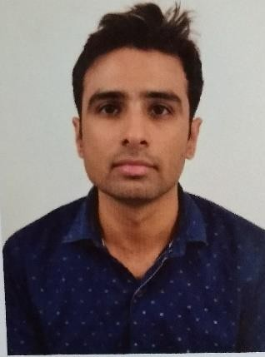
Designation | AssistantProfessor
Department | Chemistry
Qualification | M.Sc. Chemistry from Panjab UniversityChandigarh
Research | Chemicalsensors.
Experience(inyears) | Total  3.5 years |  |  | Teaching  2.5 years |  | Research  1year
ContactDetails: | E-maildeepak1nain@gmail.com |  |  |  | Mobile/Phone  8059818258
Books/ChaptersPublished
ResearchPublications | InternationalJournals |  | National  Journals |  | International  Conferences |  | National  Conferences
 | 1 |  | 0 |  | 0 |  | 0
ResearchGuidance |  | Ph.D. |  | NIL | Masters |  | NIL
ResearchProjects |  | Completed |  | NIL | In progress |  | NIL
ConsultancyProjects |  | Completed |  | NIL | In progress |  | NIL
Seminar/Conference/STTPs |  | Attended |  | NIL | Organized |  | NIL
ProfessionalAffiliations |  | PanjabUniversity,Chandigarh
Awards/Fellowshipsetc. |  | CSIRNET,GATE2017,GATE 2018, HTET and CTET

