Name | Priya |  |  |  |  |  | 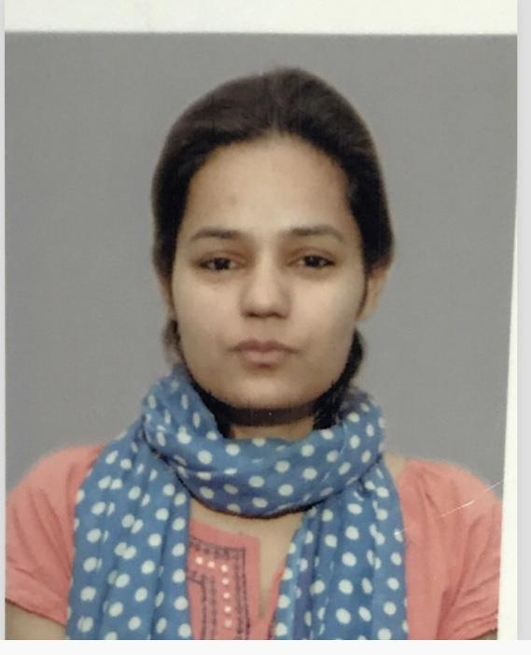
Designation | Assistant Professor
Department | Physics
Qualification | M.Sc,B.ed  GATE
Research
Experience (in years) | Total  1 |  |  | Teaching  1 |  |  | Research  NIL
Contact Details: | priyadhankhar28@gmail.com |  |  |  |  | Mobile/Phone  9991385651
Books/Chapters Published | NIL
Research Publications | International Journals |  | National Journals |  | International Conferences |  |  | National Conferences
Research Guidance |  | Ph.D. |  | NIL | Masters |  |  | NIL
Research Projects |  | Completed |  | NIL | Inprogress |  |  | NIL
Consultancy Projects |  | Completed |  | NIL | Inprogress |  |  | NIL
Seminar/Conference/STTPs |  | Attended |  | NIL | Organized |  |  | NIL
Professional Affiliations |  | NIL
Awards/ Fellowships etc. |  | NIL

