Name | MANJEET |  |  |  |  | 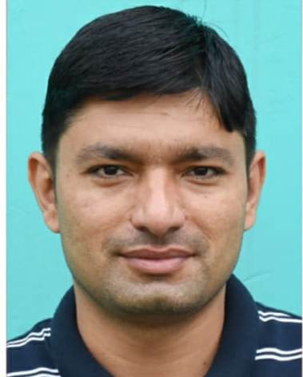
Designation | Assistant Professor
Department | Mathematics
Qualification | M.sc (2009), P.hd pursuing
Research
Experience (in years) | Total  7 years |  |  | Teaching  7 years |  | Research
Contact Details: | E-mail  mannkohar@gmail.com |  |  |  | Mobile/Phone  9466228878
Books/Chapters Published
Research Publications | International Journals |  | National Journals |  | International Conferences |  | National Conferences
 | NIL |  | NIL |  | NIL |  | NIL
Research Guidance |  | Ph.D. |  | NIL | Masters |  | NIL
Research Projects |  | Completed |  | NIL | Inprogress |  | NIL
Consultancy Projects |  | Completed |  | NIL | Inprogress |  | NIL
Seminar/Conference/STTPs |  | Attended |  | 3 seminar | Organized
Professional Affiliations |  | M.D.U. Rohtak
Awards/ Fellowships etc. |  | NIL

