Name | Dr. Rakesh Kumar |  |  |  |  | 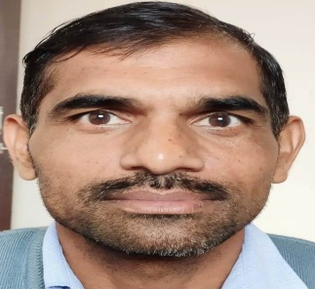
Designation | Assistant Professor (Mathematics)
Department | Mathematics
Qualification | M.Sc.(Math)(2007), Ph.D.(2017)
Research | Functional integration of two way supply chain distribution and inventory control management : A case study
Experience (in years) | Total  08 Years |  |  | Teaching  08 Years |  | Research
Contact Details: | E-mail  mathrakesh20@gmail.com |  |  |  | Mobile/Phone  9896178264
Books/Chapters Published | NIL
Research Publications | International Journals |  | National Journals |  | International Conferences |  | National Conferences
 | NIL |  | 03 |  | NIL |  | 03
Research Guidance |  | Ph.D. |  | NIL | Masters |  | NIL
Research Projects |  | Completed |  | NIL | Inprogress |  | NIL
Consultancy Projects |  | Completed |  | NIL | Inprogress |  | NIL
Seminar/Conference/STTPs |  | Attended |  | 03 | Organized |  | NIL
Professional Affiliations |  | OPJS university Churu Raj., GJU Hisar
Awards/ Fellowships etc. |  | NET(JRF)

