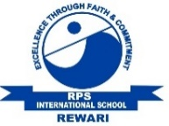 International School, Rewari
Class II
October Work Planner
Session : 2019 – 20
Dear students
A warm welcome back to another action-packed term with full enthusiasm indicating another incredible and productive school year. Rpsians are indeed a joyous and caring community with the common goals of nurturing responsible students and promoting high-level learning. Let us begin this 2nd term with joyful activities, new concepts and pleasant weather and many holidays lining up the calendar, the reason being the month has many festivals.

ENGLISH  Communicate in English  - Chapter -5, 6  - Poem - Pretending  Literature  - Chapter – 6  Grammar  - Chapter – 16, 17, 18, 19  MATHS  - Unit 9 (Multiplication)  - Unit 11 (Fraction) | EVS  - Chapter- 7, 8  GK  October month magazine and September month magazine  HINDI  पाठ्यपुस्तक-  - पाठ 8 (इंडिया गेट)  - पाठ 9 (मिनी का ई-मेल)  व्याकरण –  - पाठ 8 (विशेषण)  - पाठ 9 (क्रिया)) | COMPUTER  - Chapter- 6, 7  SPORTS  Karate and Skating  DANCE  - Dandia, Garba  MUSIC  - Prayers and Hymns  ART  - Page no. 21 to 30

Activities and Competitions of the month:-  - Gandhi Jayanti  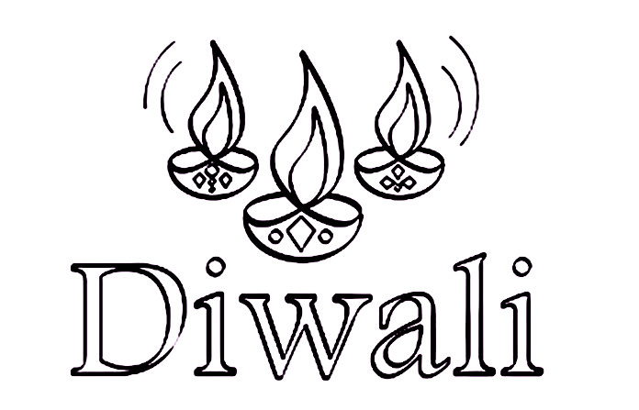  - Navratri  - Dusshera  - Diwali  - World Food Day | Holidays of the month:-  - Dusshera (8th October 2019)  - 2nd Saturday (12th October 2019)  - Karwa Chauth (17th October 2019)  - Diwali break (25th October to 29th October 2019)

PTM of the month:- 6th October 2019 (Sunday)

Class Teacher’s Signature Coordinator’s Signature Principal’s Signature

Note:- Work planner may subject to minor changes.

International School, Rewari
Class II
October Work Planner
Session : 2019 – 20
Dear students
A warm welcome back to another action-packed term with full enthusiasm indicating another incredible and productive school year. Rpsians are indeed a joyous and caring community with the common goals of nurturing responsible students and promoting high-level learning. Let us begin this 2nd term with joyful activities, new concepts and pleasant weather and many holidays lining up the calendar, the reason being the month has many festivals.

